DISHES AND THEIR ALLERGEN CONTENT – Mill Hill Primary School Spring/Summer Menu 2023 (d)

DISHES | 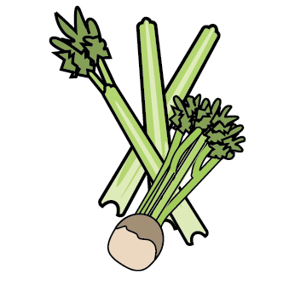 | 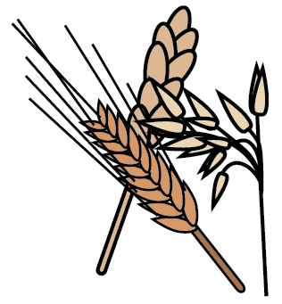 | 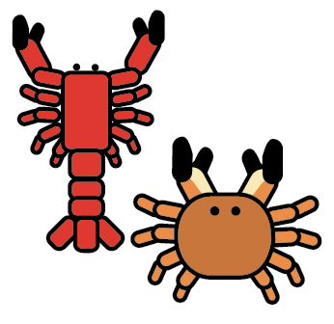 |  |  |  |  |  | 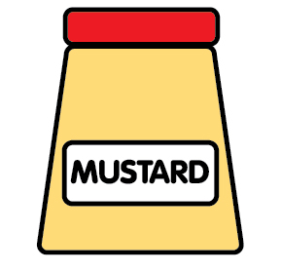 | 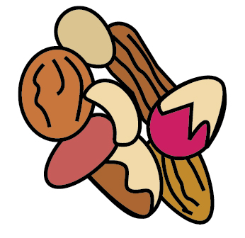 | 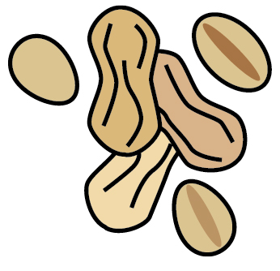 | 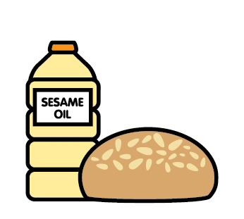 |  | 
 | Celery | Cereals containing gluten | Crustaceans | Eggs | Fish | Lupin | Milk | Mollusc | Mustard | Nuts | Peanuts | Sesame seeds | Soya | Sulphur Dioxide
Quorn Burger in a Bun |  | ✓ |  | ✓ |  |  | ✓ |  |  |  |  | ✓
Quorn Sausage |  | ✓
Chicken Curry & Rice |  | ✓ |  |  |  |  |  |  | ✓
Sausage Roll |  | ✓ |  |  |  |  | ✓ |  |  |  |  |  | ✓ | Sulphite
Cheeseburger | ✓ | ✓ |  | ✓ |  |  | ✓ |  |  |  |  | ✓
Pork Steak & Yorkshire Pudding |  | ✓ |  | ✓ |  |  | ✓
Fishfinger |  | ✓ |  |  | ✓
Naan Bread |  | ✓
Shortbread |  | ✓ |  | ✓ |  |  | ✓

Review date: |  | Reviewed by: |  |  | You can find this template, including more information at www.food.gov.uk/allergy

