DISHES AND THEIR ALLERGEN CONTENT – Mill Hill Primary School Spring/Summer Menu 2023 (e)

DISHES | 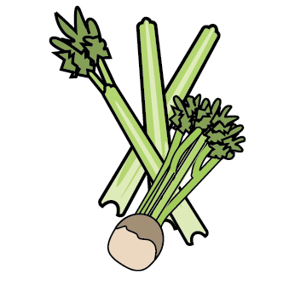 | 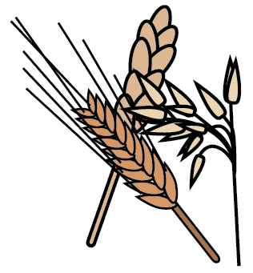 | 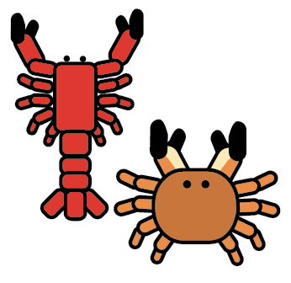 | 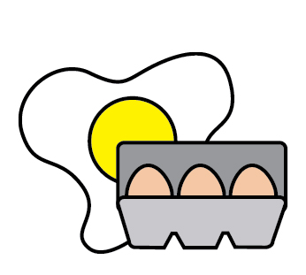 |  |  |  | 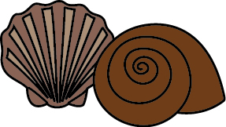 | 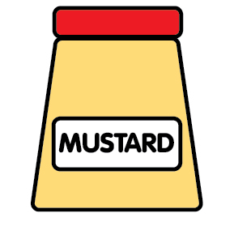 | 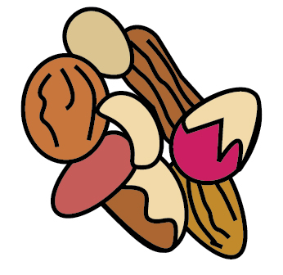 | 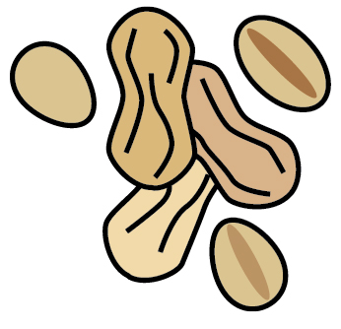 | 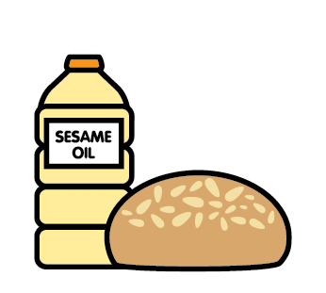 |  | 
 | Celery | Cereals containing gluten | Crustaceans | Eggs | Fish | Lupin | Milk | Mollusc | Mustard | Nuts | Peanuts | Sesame seeds | Soya | Sulphur Dioxide
Chocolate Sponge & Custard |  | ✓ |  | ✓ |  |  | ✓
Pancake & Icecream |  | ✓ |  | ✓ |  |  | ✓ |  |  |  |  |  | ✓ | Palm Oil

Review date: |  | Reviewed by: |  |  | You can find this template, including more information at www.food.gov.uk/allergy

