DISHES AND THEIR ALLERGEN CONTENT – Mill Hill Primary School Spring/Summer Menu 2023 (b)

DISHES | 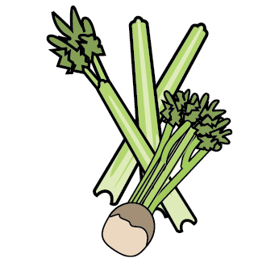 | 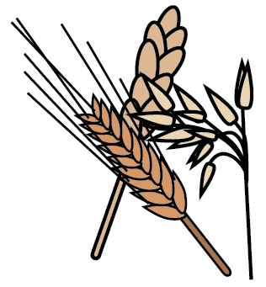 | 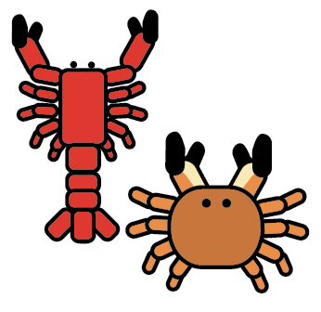 |  |  |  |  |  | 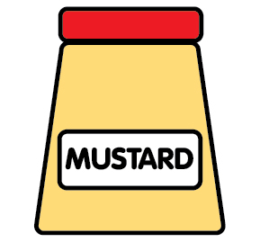 | 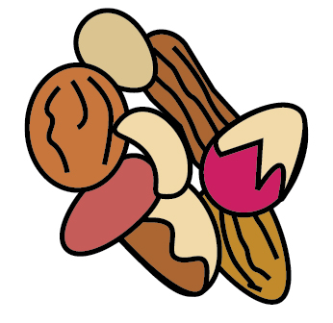 | 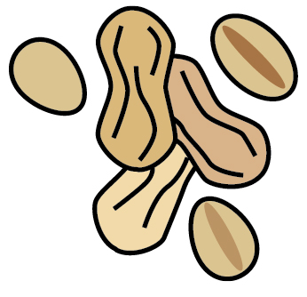 | 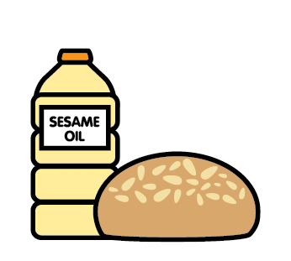 |  | 
 | Celery | Cereals containing gluten | Crustaceans | Eggs | Fish | Lupin | Milk | Mollusc | Mustard | Nuts | Peanuts | Sesame seeds | Soya | Sulphur Dioxide
Garlic Bread |  | ✓ |  |  |  |  | ✓ |  |  |  |  | ✓
Mashed Potato |  |  |  |  |  |  | ✓
Bread |  | ✓
Spicy Vegetable Wrap |  | ✓
Quorn Burger |  | ✓ |  | ✓ |  |  | ✓ |  |  |  |  | ✓
Quorn Mince & Dumplings |  | ✓
Quorn Sausage & Yorkshire Pudding |  | ✓ |  | ✓ |  |  | ✓
Cheese & Tomato Pizza |  | ✓ |  |  |  |  | ✓ |  |  |  |  | ✓
Beef Bolognaise |  | ✓

Review date: |  | Reviewed by: |  |  | You can find this template, including more information at www.food.gov.uk/allergy

