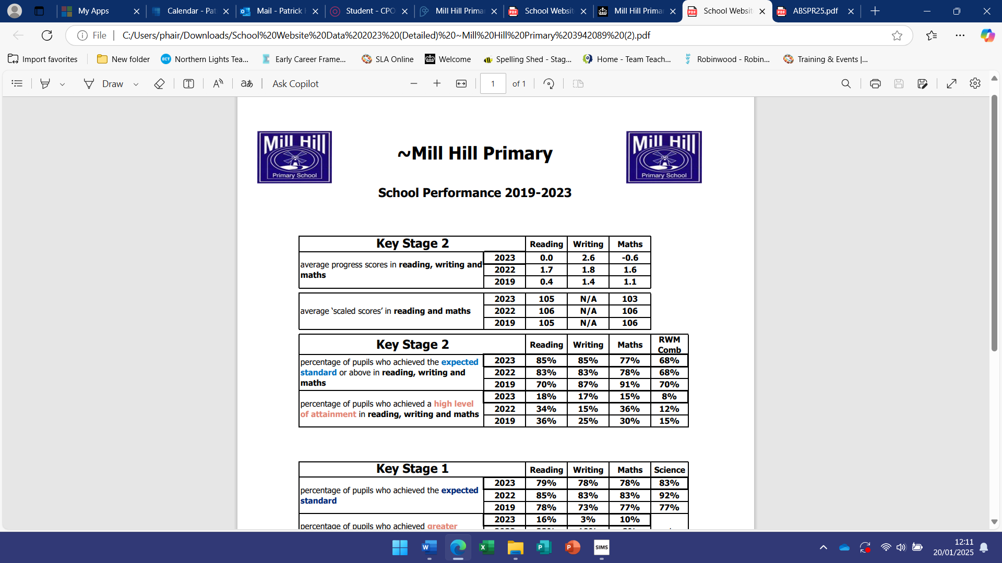

**School Performance 2022-2024**

|  |  |  |  |  |
| --- | --- | --- | --- | --- |
| Key Stage 2 | Year | Reading | Writing | Maths |
| Average progress scores in reading, writing and maths | 2024 | N/A | N/A | N/A |
| 2023 | 0.0 | 2.6 | - 0.6 |
| 2022 | 1.7 | 1.8 | 1.6 |

|  |  |  |  |  |
| --- | --- | --- | --- | --- |
| Key Stage 2 | Year | Reading | Writing | Maths |
| Average scaled scores in reading and maths | 2024 | 108 | N/A | 107 |
| 2023 | 105 | N/A | 103 |
| 2022 | 106 | N/A | 106 |

|  |  |  |  |  |  |
| --- | --- | --- | --- | --- | --- |
| Key Stage 2 | Year | Reading | Writing | Maths | RWM |
| Percentage of pupils who achieved the expected standard or above in reading writing and maths | 2024 | 90% | 90% | 90% | 83% |
| 2023 | 85% | 85% | 77% | 68% |
| 2022 | 83% | 83% | 78% | 68% |
| Percentage of pupils who achieved a high level of attainment in reading writing and maths | 2024 | 40% | 15% | 29% | 7% |
| 2023 | 18% | 17% | 15% | 8% |
| 2022 | 34% | 15% | 36% | 12% |

|  |  |  |  |  |  |
| --- | --- | --- | --- | --- | --- |
| Key Stage 1 | Year | Reading | Writing | Maths | Science |
| Percentage of pupils who achieved the expected standard | 2024 | N/A | N/A | N/A | N/A |
| 2023 | 79% | 78% | 78% | 83% |
| 2022 | 85% | 83% | 83% | 92% |
| Percentage of children who achieved greater depth | 2024 | N/A | N/A | N/A | N/A |
| 2023 | 16% | 3% | 10% |
| 2022 | 22% | 10% | 8% |

|  |  |  |
| --- | --- | --- |
| Phonics Screening Check | Year | Year 1 |
| Percentage of children who achieved the expected standard (32/40) | 2024 | 93% |
| 2023 | 83% |
| 2022 | 83% |

|  |  |  |
| --- | --- | --- |
| Early Years Foundation Stage | Year | Good Level Of Development |
| Percentage of pupils who achieved the good level of development | 2024 | 70% |
| 2023 | 72% |
| 2022 | 63% |

|  |  |  |  |
| --- | --- | --- | --- |
| Year 4 Multiplication Tables Check | Percentage of children achieving 25/25 | School mean points score | National mean points score |
| 2024 | 40% | 22 | * |
| 2023 | 48% | 22.6 | 20.2 |
| 2022 | 17% | 20.4 | 19.8 |

* Not available