DISHES AND THEIR ALLERGEN CONTENT – Mill Hill Primary School (Spring Menu Week 3 Wednesday)

DISHES | 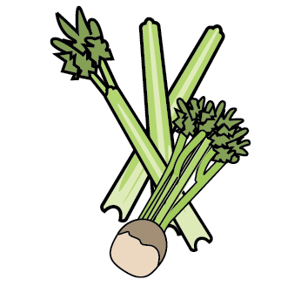 | 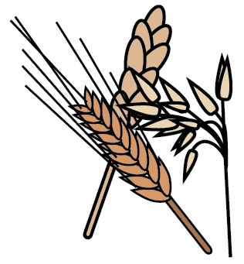 | 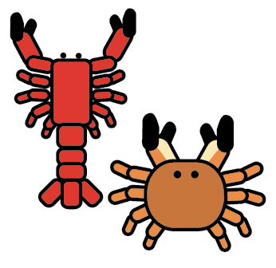 | 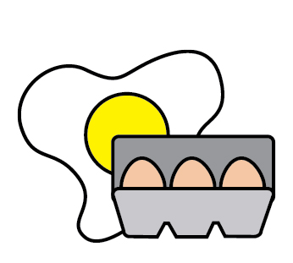 |  | 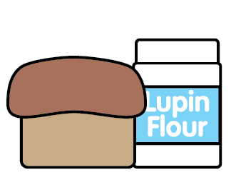 |  | 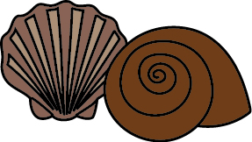 | 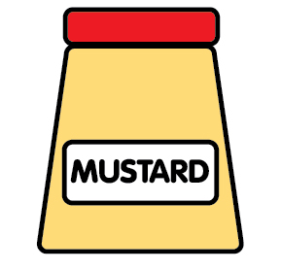 | 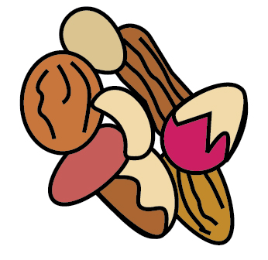 | 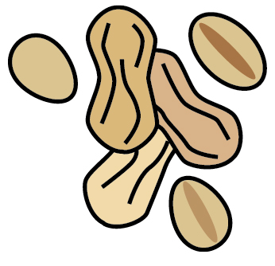 | 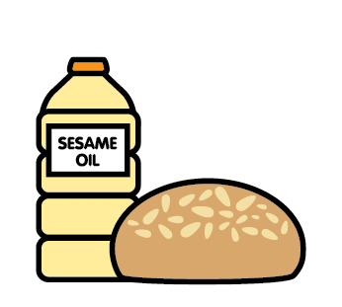 |  | 
 | Celery | Cereals containing gluten | Crustaceans | Eggs | Fish | Lupin | Milk | Mollusc | Mustard | Nuts | Peanuts | Sesame seeds | Soya | Sulphur Dioxide
Quorn Sausage |  | ✓
Hot Dog in a Bun |  | ✓
Pommes & Veg |  | ✓
Jacket Potato with cheese, tuna mayo or beans |  |  |  | ✓ | ✓ |  | ✓
Sandwiches with ham, cheese or tuna |  | ✓ |  |  | ✓ |  | ✓
Yoghurt |  |  |  |  |  |  | ✓
Chocolate Cup Cake with White Chocolate Chip |  | ✓ |  | ✓ |  |  | ✓ |  |  |  |  |  | ✓
Salad bar/bread |  | ✓ |  |  |  |  |  |  |  |  |  | ✓

Review date: |  | Reviewed by: |  |  | You can find this template, including more information at www.food.gov.uk/allergy

