
Being a Geographer

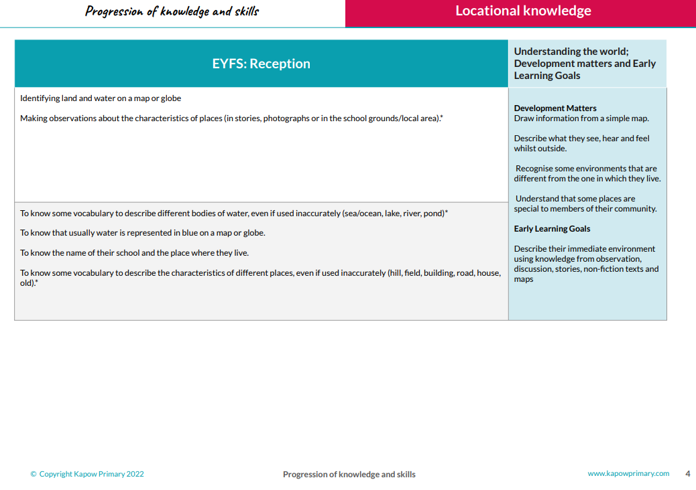
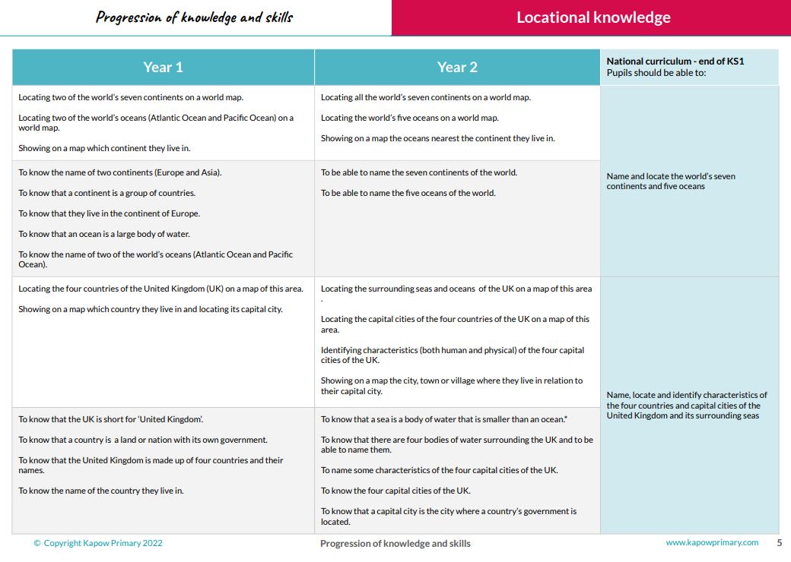
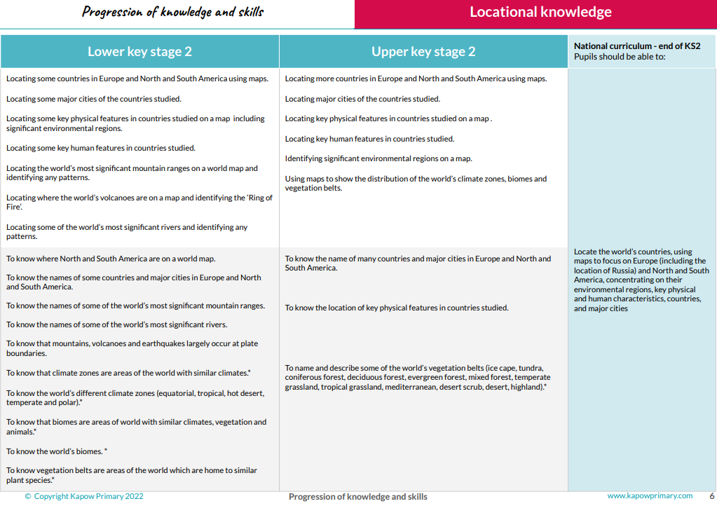
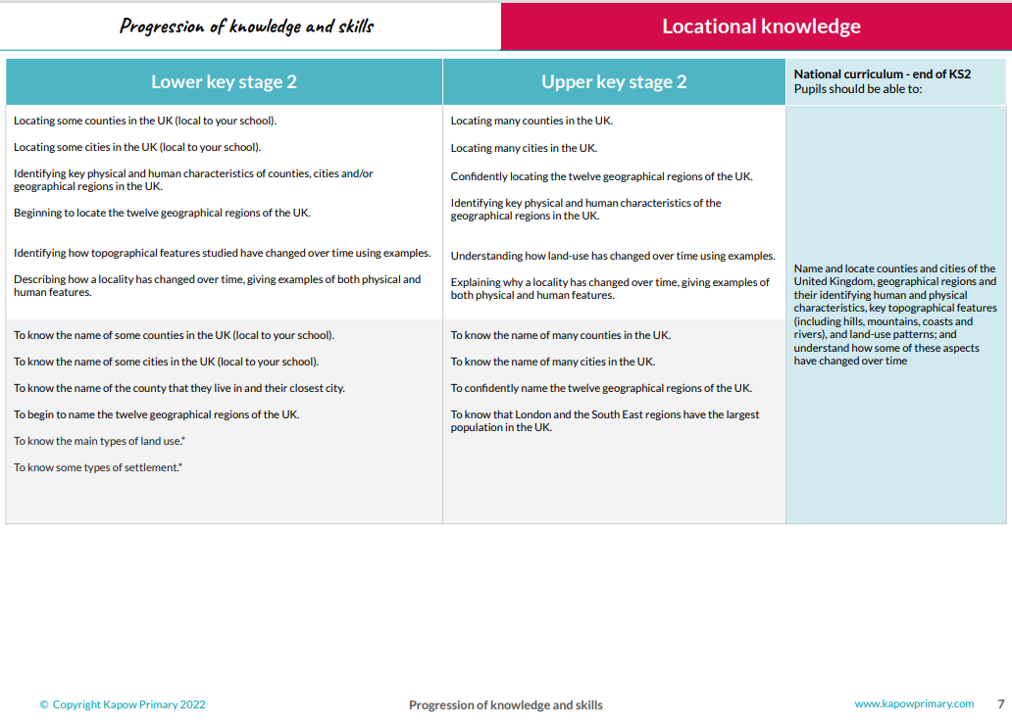

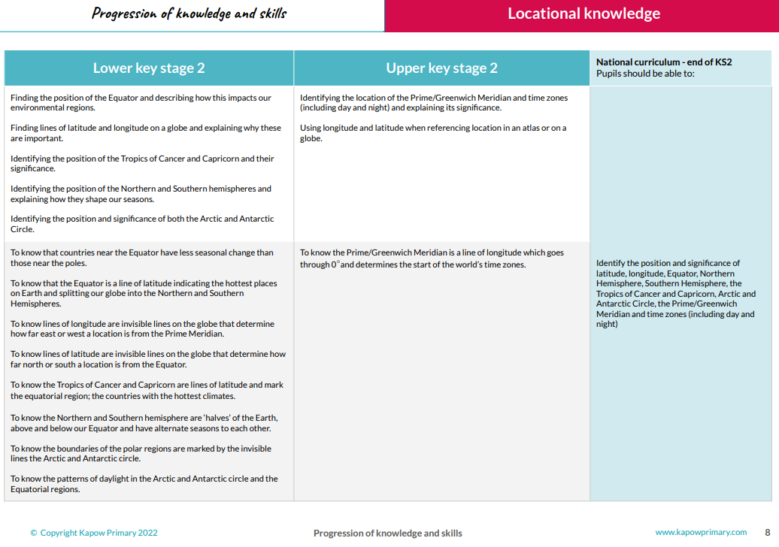

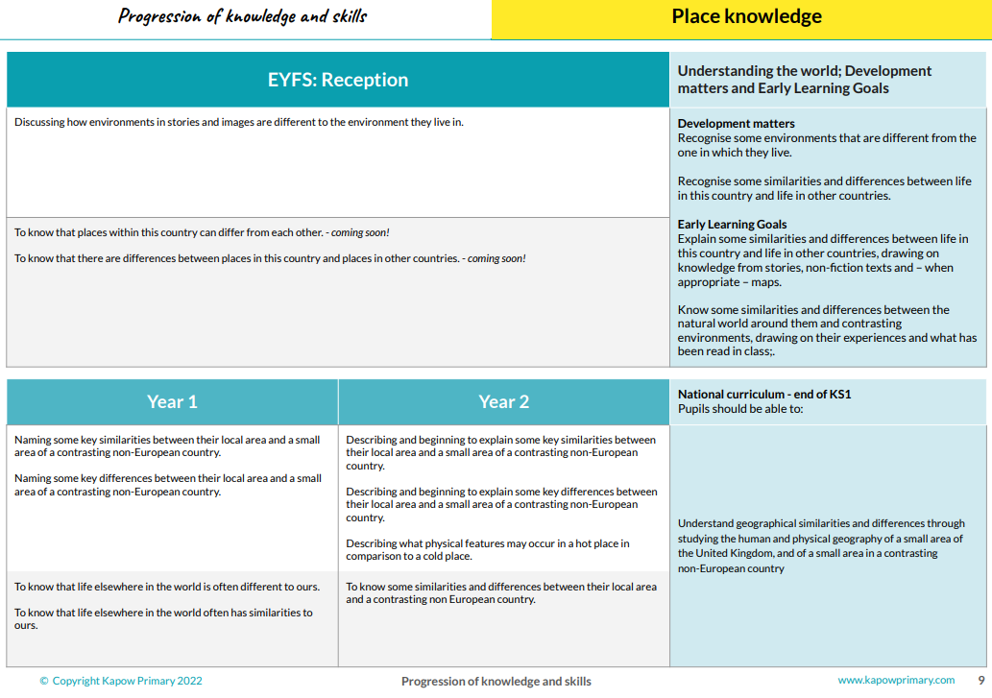

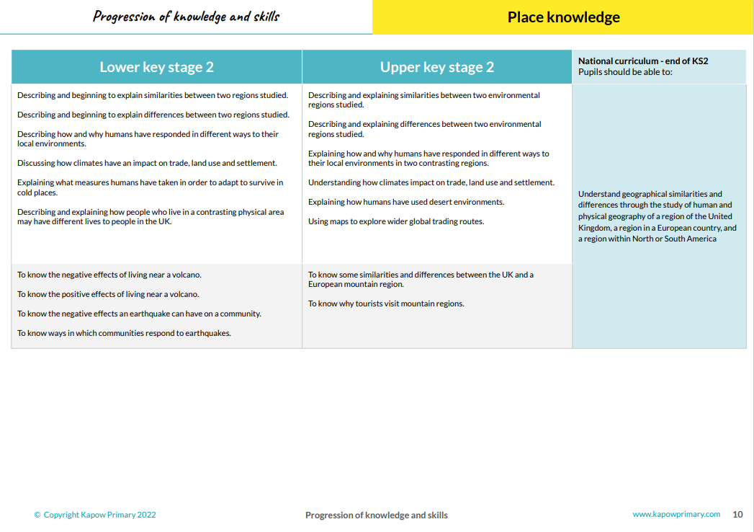

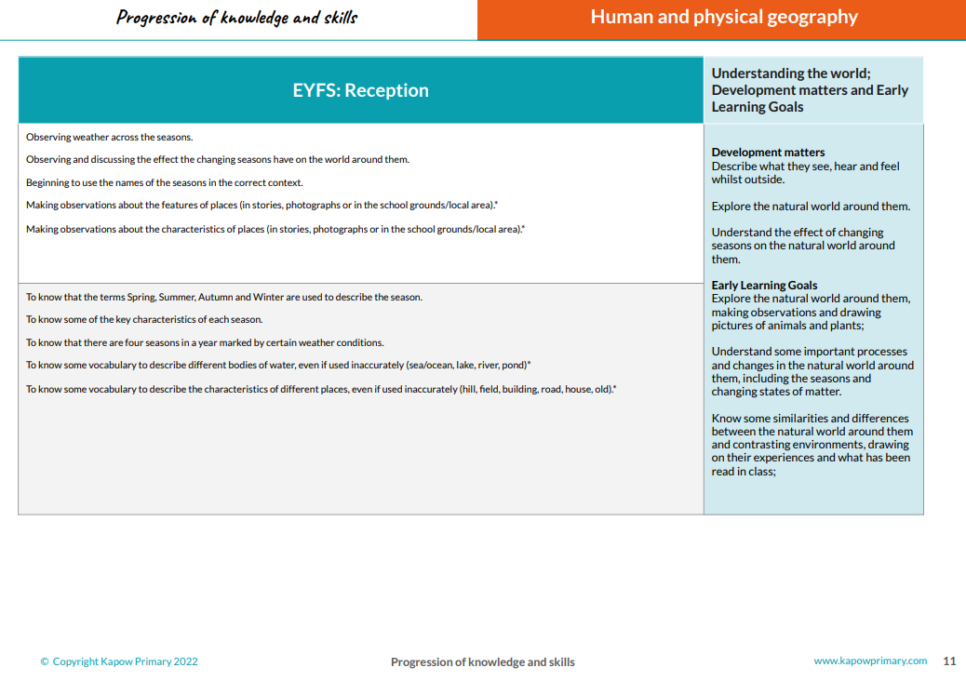

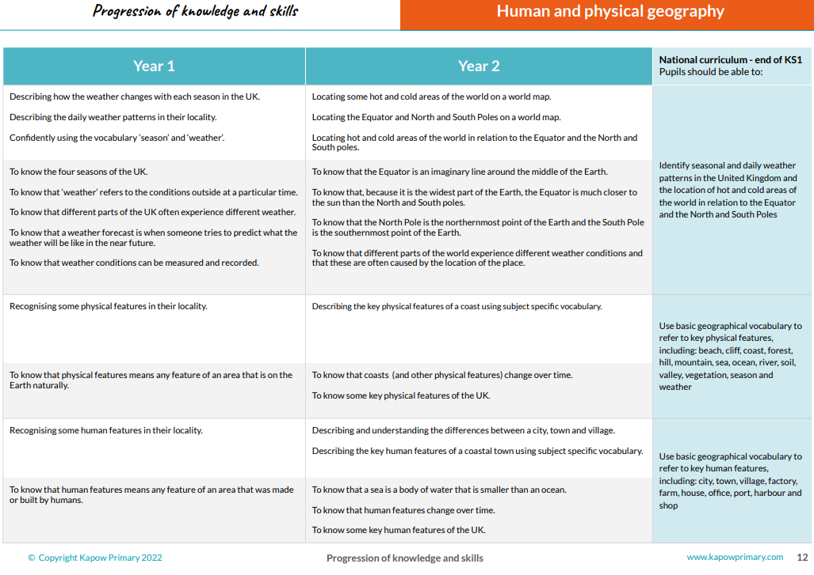

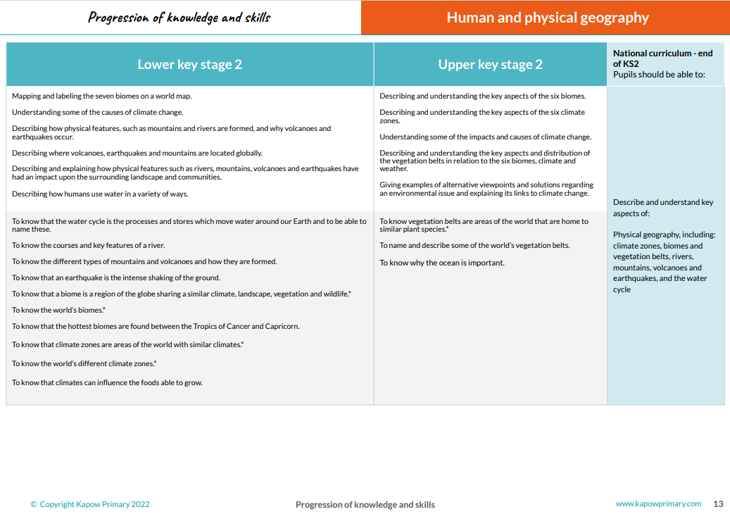

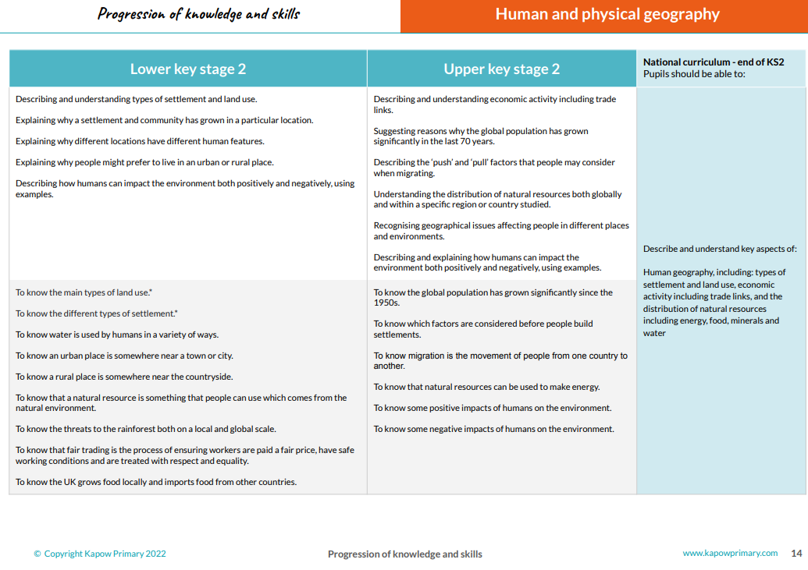

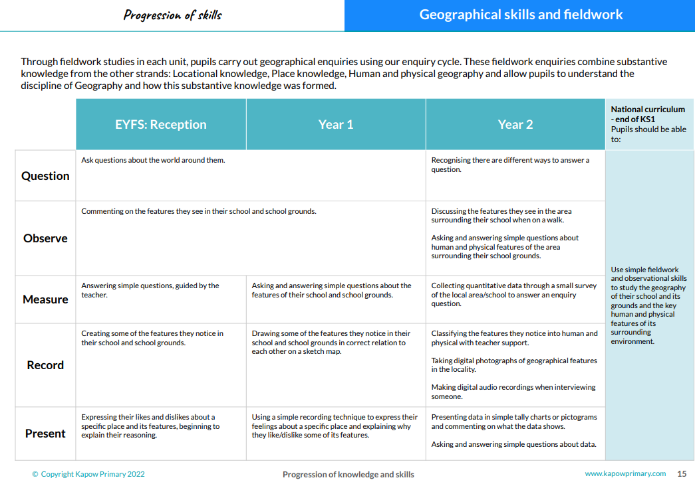

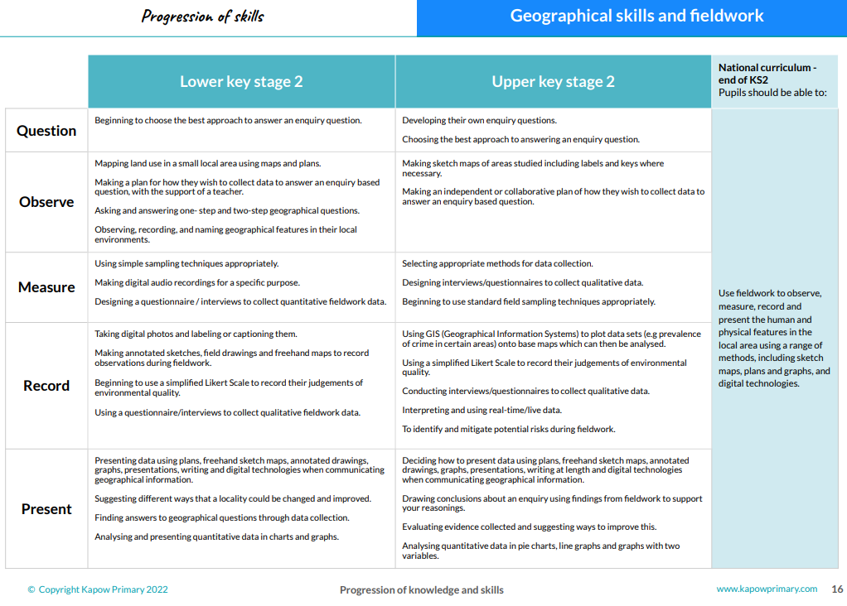

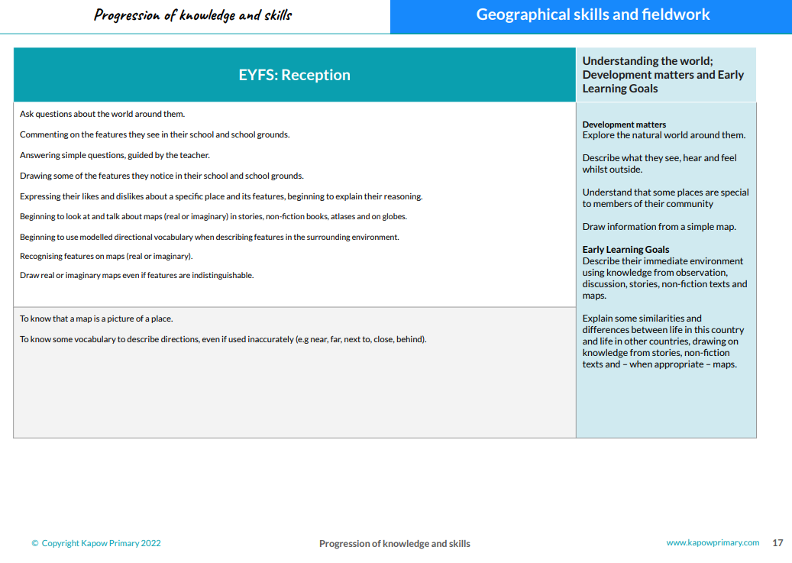

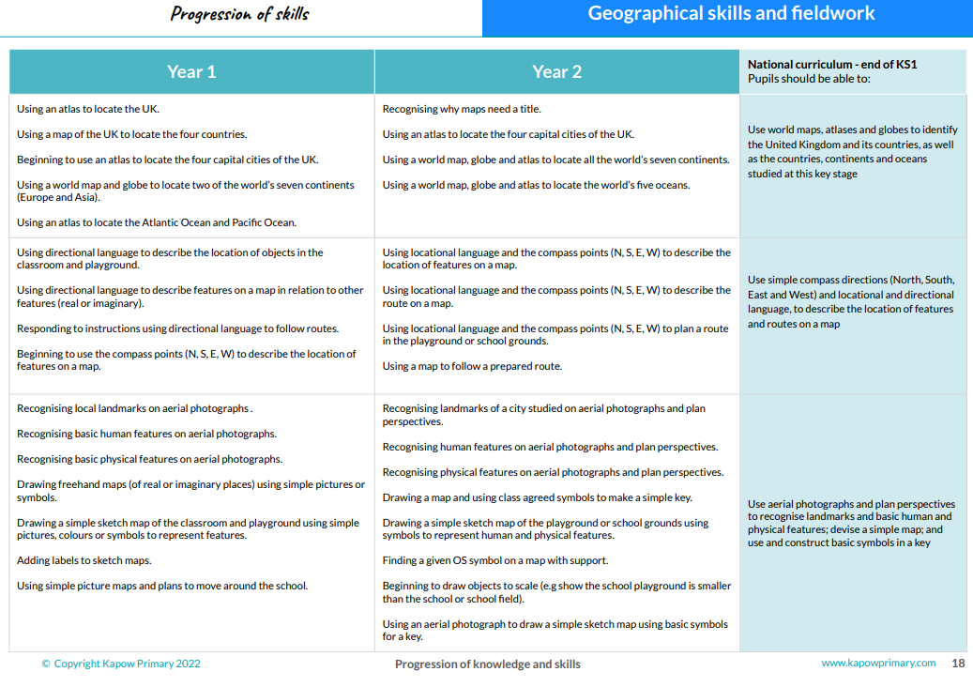

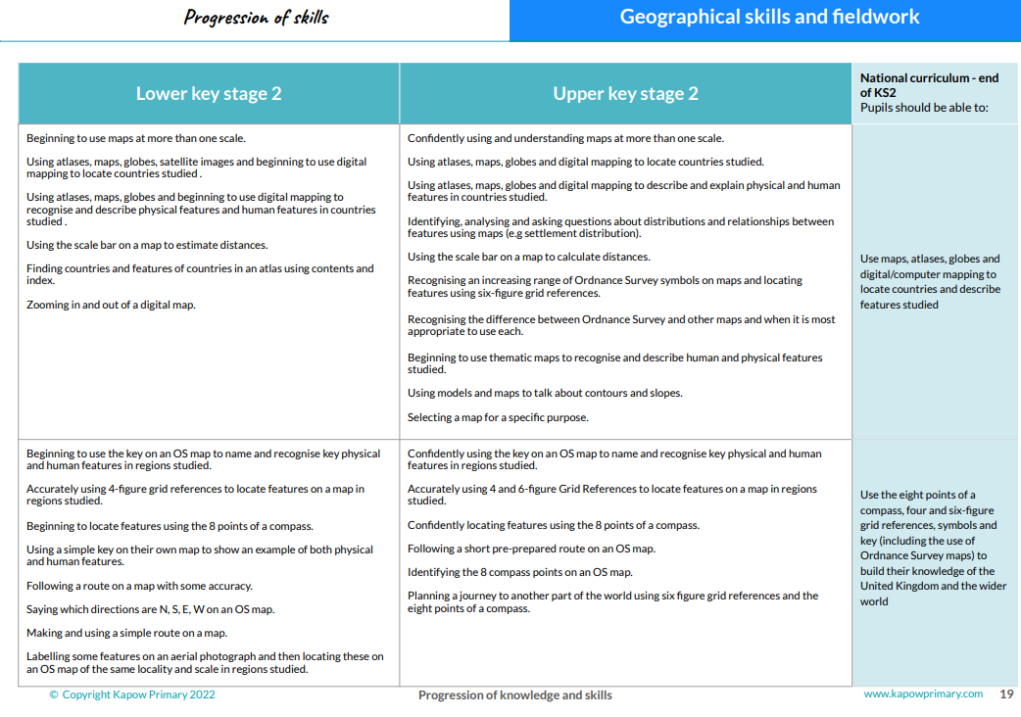

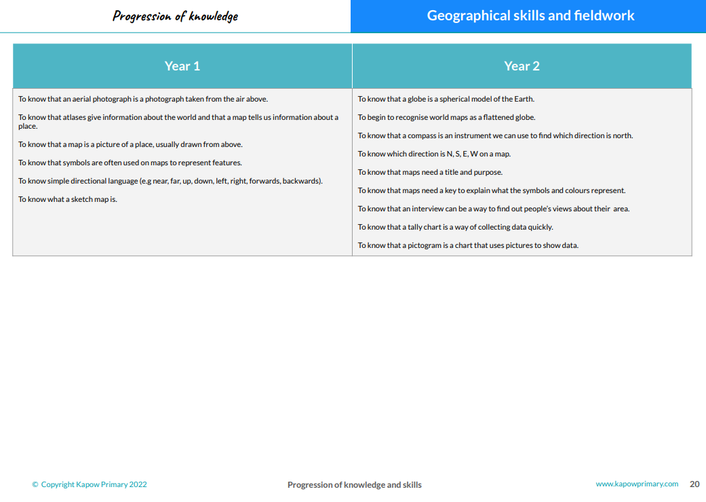

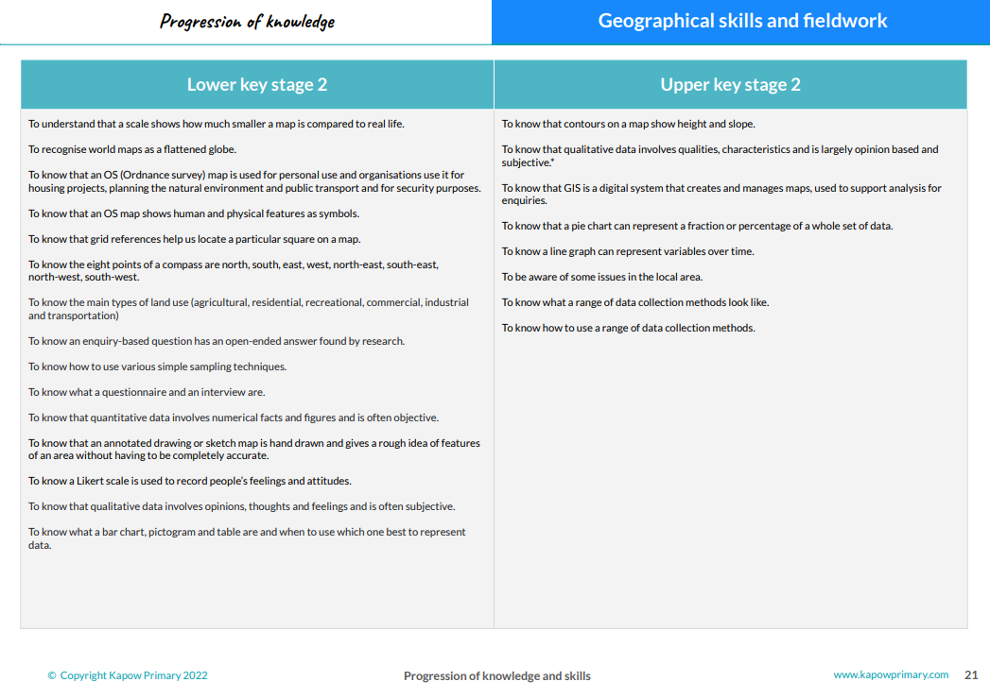

EYFS Geography

Term | Autumn 1 | Autumn 2 | Spring 1 | Spring 2 | Summer 1 | Summer 2
EYFS Topic Focus | Ourselves, Our families & Our Community  Outdoor learning focus; Summer/ Autumn transition | Light and Dark  Outdoor learning focus; Autumn/ Winter time | Dragons, Knights and Traditional Tales  Outdoor learning focus; Winter time | New Life and Growth  Outdoor learning focus; spring time | All things great and small  Outdoor learning focus; spring/summer transition | Transport- Here, There and Everywhere!  Outdoor learning focus; summer time
Locational Knowledge | To know there are different countries in the world and talk about the differences they have experienced. |  | To draw information from a map.  To know that simple symbols are used to identify features of a map | To know that simple symbols are used to identify features of a map | To know that there are many countries around the world.
Place Knowledge | To know about features of the immediate environment. | To talk about members of the local community | To know about features of the world and Earth | To compare and explore differences in life in this country and other countries
Human and Physical Geography | To use all their senses in a hands-on exploration of natural materials. | To know about and recognise the signs of Autumn | To know about and recognise the signs of Winter | To know about and recognise the signs of Spring |  | To know about and recognise the signs of Summer
Geographical Skills and Fieldwork |  |  |  |  | To respect and care for the natural environments

