DISHES AND THEIR ALLERGEN CONTENT – Mill Hill Primary School (Breakfast Club)

DISHES | 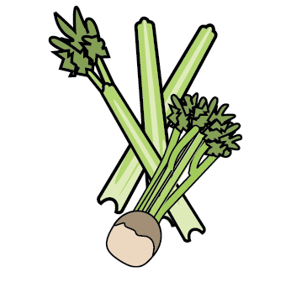 | 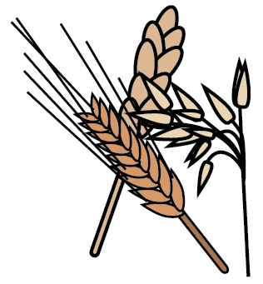 | 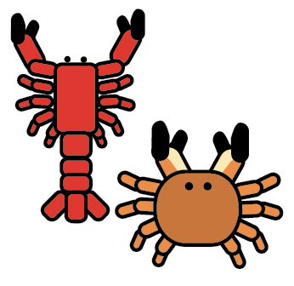 | 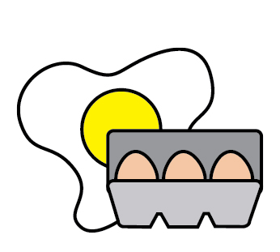 | 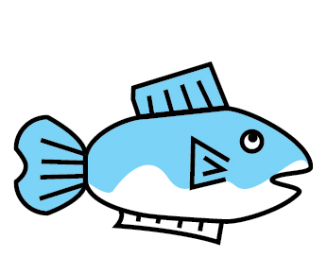 | 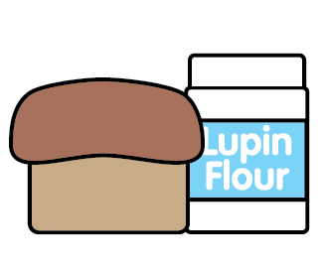 |  | 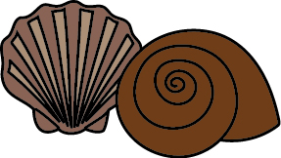 | 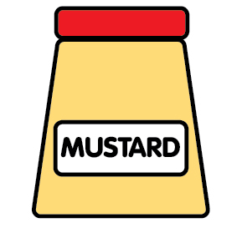 | 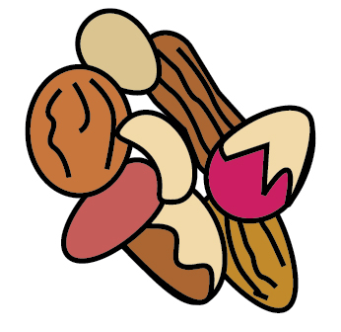 | 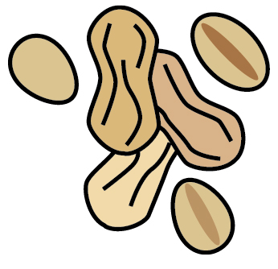 | 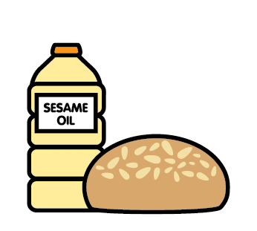 |  | 
 | Celery | Cereals containing gluten | Crustaceans | Eggs | Fish | Lupin | Milk | Mollusc | Mustard | Nuts | Peanuts | Sesame seeds | Soya | Sulphur Dioxide
Bacon Bun |  | ✓ |  |  |  |  |  |  |  |  |  | May Contain
Bacon Sandwich |  | ✓ |  |  |  |  |  |  |  | May Contain |  | May Contain
Sausage Bun |  | ✓ |  |  |  |  |  |  |  |  |  | May Contain
Sausage Sandwich |  | ✓ |  |  |  |  |  |  |  | May Contain |  | May Contain
Egg Bun |  | ✓ |  | ✓ |  |  |  |  |  |  |  | May Contain
Egg Sandwich |  | ✓ |  | ✓ |  |  |  |  |  | May Contain |  | May Contain
Cheerios |  | ✓ |  |  |  |  | ✓ |  |  | May Contain
Frosties |  | ✓ |  |  |  |  | ✓ |  |  | May Contain
Toast |  | ✓ |  |  |  |  | ✓ |  |  |  |  |  | ✓

Review date: |  | Reviewed by: |  |  | You can find this template, including more information at www.food.gov.uk/allergy

