Term Dates 2026/2027

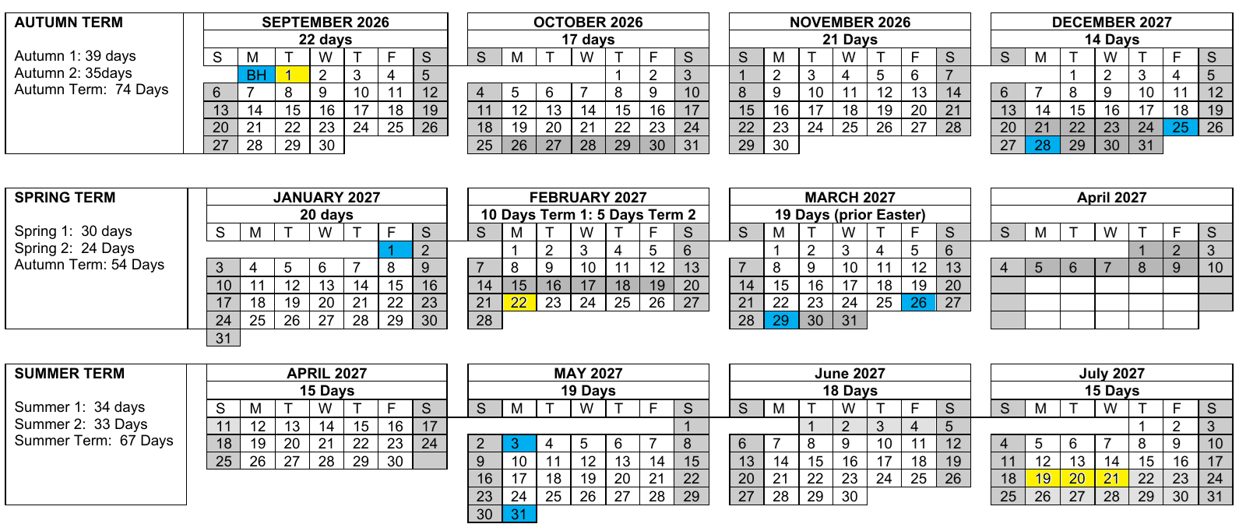

Total Number of Days within the academic year: 195 Schools Must be open to pupils for 190 days. Staff must be available for work on a further 5 days (195 in total) or the equivalent for in-service training. Schools will re-open on Monday 6th September 2027
Bank Holiday
Inset Days

