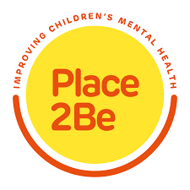

Dear Parents/Carers,

I am writing to let you know about our school’s work with Place2Be, a national charity supporting schools to improve the confidence and wellbeing of children and young people.

Place2Be provides emotional and therapeutic support to children and young people, families and staff in more than 450 schools nationwide.

It gives children and young people a space to express themselves through talking and creative work, and to think about any worries they might have. Place2Be also provides support for parents and staff too. Some information is enclosed to tell you more about Place2Be and its work.

Place2Talk

One of the most popular aspects of this service is called ‘Place2Talk’. It’s open to all children and young people at Mill Hill School, and they can make an appointment to spend 10 minutes with a trained counsellor, either by themselves or with a friend. On average, about a third of children and young people who access the service in schools take advantage of this service every year. Children and young people often talk about friendships or any worries they may have.

Place2Be will record your child’s name, date of birth, year group, gender, ethnicity, the broad topic of discussion and any actions taken as a result of the session. This information is stored securely. It is used in key coded form to evaluate Place2Be’s service and improve our work. Please see the separate sheet, at the end of this letter, for more information on this

Parental Agreement for Accessing Place2Talk

Unless we hear otherwise from you, the school and Place2Be will assume that your child has parent/carers’ permission to come to Place2Talk.

If would like to find out more, or would prefer that your child does not use this service, please contact Susie, who our is our School Project Manager
Email address susannah.kay@place2be.org.uk who will be very happy to answer any questions.

……………………………………………………………………………………………….

I do not want my child to participate in Place2Talk.

Name of child/young person……………………...………………………. Class/form ………………….

Name of parent/carer ………………………………. . ………………………………………

Signature ………………………………………….. Date ………………………..

