Early Years Foundation Stage (EYFS) policy
Mill Hill Primary School

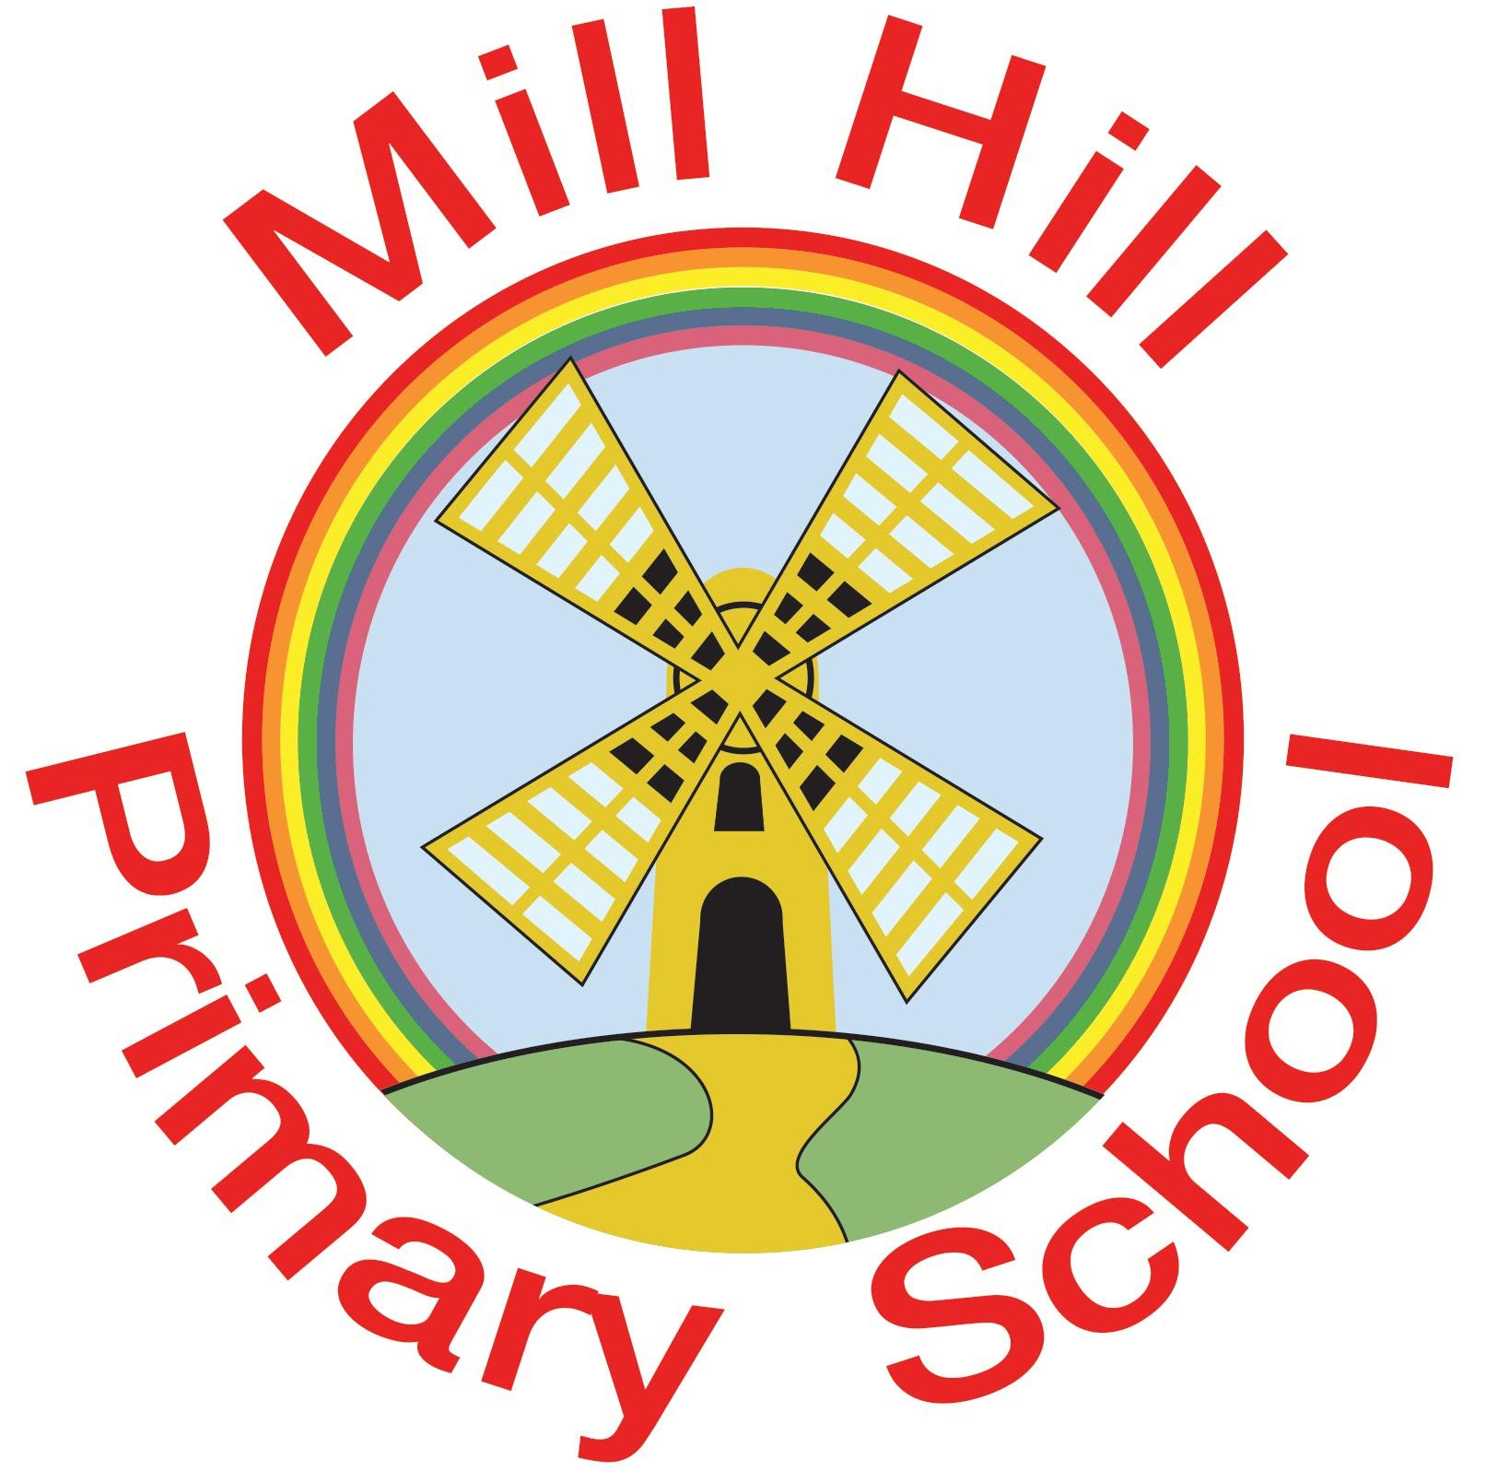
Aspire-Learn-Succeed

Contents
1. Aims 3
2. Legislation 3
3. Structure of the EYFS 3
4. Curriculum 3
5. Assessment 4
6. Working with parents 5
7. Safeguarding and welfare procedures 4
8. Monitoring arrangements 4
Appendix 1. List of statutory policies and procedures for the EYFS

1. Aims
This policy aims to ensure:
- That children access a broad and balanced curriculum that gives them the extensive range of knowledge and skills needed for good progress through school and life
- Quality and consistency in teaching and learning so that every child makes good progress and no child gets left behind
- A close working partnership between staff and parents and/or carers
- Every child is included and supported through equality of opportunity and anti-discriminatory practice

  - Our Vision
In EYFS at Mill Hill we aim to ensure all of our children leave reception confident and autonomous learners who have a curiosity and excitement for learning. We want to equip children with the skills to develop and progress and enjoy the curiosity of the wider world around them. We want our children to have empathy for others and develop strong peer relationships. We want to provide learning opportunities that inspire children to be creative, curious and resilient.

  - Our Mission
In reception we aim to create curious, autonomous learners by;
- providing children with the opportunity to take ownership and responsibility for their own play and environments.
- Give children a voice and choice in the direction of their learning
- Strong home- school links which allow us to have a deeper understanding of the child and their interest and needs
- Give them opportunities to make mistakes
- Creating an open-ended learning environment which challenges the children to create their own learning opportunities
- Spending time with the children during independent learning to help move their learning on and gain a deeper insight into what they know, need and do.

1.3 Intent
The Foundation Stage underpins all future learning by promoting and developing:
- Personal, social and emotional well-being, including developing secure attachments, supporting the management of emotions, developing a positive sense of self, learning how to look after their bodies (healthy life styles and managing personal needs independently)
- Language and communication in a range of language rich environments that allow for back-and-forth conversations, commenting and echoing and frequent reading to allow children to thrive.
- Literacy; our aim is for children to develop a lifelong love of reading through language comprehension which starts from birth and involves providing opportunities for children to talk about the world around them. Children explore books, poetry and songs together and develop word reading through speedy decoding work, writing and composition.
- Mathematics; a strong grounding in number to allow all children to develop the necessary building blocks to excel, whilst also providing frequent and varied opportunities to build and apply this understanding and opportunities for children to develop their spatial reasoning skills.
- An understanding of our diverse world through guiding children to make sense of their physical world and communities, drawing on personal experiences and listening to a broad range of stories.
- Physical development, enabling children to develop and practise fine and gross motor skills and develop strength, proficiency, control and confidence through repeated and varied opportunities for play both indoors and outdoors
- Expressive arts and design support children’s imagination and creativity through regular in-depth opportunities to explore and play with a wide range of quality and varied media and materials.

2. Legislation
This policy is based on requirements set out in the statutory framework for the Early Years Foundation Stage (EYFS) that applies from September 2021.
This document also complies with our funding agreement and articles of association.

3. Structure of the EYFS
The Early Years Foundation Stage (EYFS) extends from birth to the end of the reception year. At Mill Hill Primary School entry is at the beginning of the school year in which the children are four and five (although compulsory schooling does not begin until the start of the term after a child's fifth birthday).
We plan a safe and secure learning environment, both indoors and outdoors, that encourages a positive attitude to learning and development coupled with secure routines for play and learning. There are specific areas that offer a range of different experiences that allow our children to engage, explore and investigate. We use materials and equipment that reflect both the community that the children come from and the wider world. We create an enabling environment where adults respond to the individual interests and needs of each child and help them to build their learning over time. Reception has its own enclosed outdoor area but the children also access the further school grounds for outdoor learning activities.

4. Curriculum
Our early years setting follows the curriculum as outlined in the latest version of the EYFS statutory framework that applies from September 2021.
The EYFS framework includes 7 areas of learning and development that are equally important and inter-connected. However, 3 areas known as the prime areas are seen as particularly important for igniting curiosity and enthusiasm for learning, and for building children’s capacity to learn, form relationships and thrive.
The prime areas are:
- Communication and language
- Physical development
- Personal, social and emotional development

The prime areas are strengthened and applied through 4 specific areas:
- Literacy
- Mathematics
- Understanding the world
- Expressive arts and design

4.1 Planning
Staff plan activities and experiences that enable children to develop and learn effectively. Staff also take into account the individual needs, interests, and stage of development of each child in their care, and use this information to plan a challenging and engaging curriculum. Where a child may have special educational needs or disabilities, staff consider whether specialist support is required, linking with relevant services from other agencies, where appropriate. In planning and guiding children’s activities, staff reflect on the different ways that children learn and include these in their practice.
Practitioners use assessment from the children’s previous settings alongside ongoing day to day observations to plan and respond to children’s emerging needs in order to guide their progress towards the expected level of development at the end of the reception year. Discrete teaching of phonics, maths and reading is intermixed with this, allowing staff to create learning experiences that account for the children’s next steps in learning as well as responding to the needs and interests of the children. Medium term planning is completed half termly and identifies the essential skills and knowledge which children need to progress in specific areas of learning.

4.2 Teaching
Each area of learning and development is implemented through planned, purposeful play, and through a mix of adult-led and child-initiated activities. Staff respond to each child’s emerging needs and interests, guiding their development through warm, positive interaction.
As children grow older, and as their development allows, the balance gradually shifts towards a greater focus on teaching the essential skills and knowledge in the specific areas of learning to help prepare children for year 1.
We ensure that our environment and delivery of the curriculum incorporates the three characteristics of learning.
- Playing and Exploring
We aim to provide a challenging environment which supports and extends children’s learning through planned activities covering all aspects of the foundation stage curriculum. Alongside this we also allow children periods of uninterrupted play in which they can actively explore their environment, set their own challenges and make their own discoveries.

- Active Learning
We aim to provide children with independence and control over their learning. We aim to foster determination and resilience within the setting through learning opportunities that allow children to develop their concentration, problem solving skills and explore how to overcome challenges.

- Creativity and Critical Thinking
Children are given opportunities to develop their own ideas, make links between ideas and develop strategies for doing things through open access to resources, the autonomy to move around their environment independently and support in the form of open-ended questions and clarifying if needed.

5. Assessment
At Mill Hill ongoing assessment is an integral part of the learning and development process. Staff observe pupils to identify their level of achievement, interests and learning styles. These observations are used to shape future planning. Staff also take into account observations shared by parents and/or carers.
Within the first 6 weeks that a child starts reception, staff will administer the Reception Baseline Assessment (RBA).
At the end of the EYFS, staff complete the EYFS profile for each child. Pupils are assessed against the 17 early learning goals, indicating whether they are:
- Meeting expected levels of development
- Not yet reaching expected levels (‘emerging’)
The profile reflects ongoing observations, and discussions with parents and/or carers. The results of the profile are shared with parents and/or carers for their child. The profile is moderated internally (referring to the Development Matters guidance) and in partnership with other local schools and the local authority, to ensure consistent assessment judgements. EYFS profile data is submitted to the local authority.
The Foundation Stage Profile is the nationally employed assessment tool that enables
teachers to record their observations at the end of the Foundation Stage, and to summarise their pupils' progress towards and beyond the Early Learning Goals. It covers each of the seven areas of learning contained in the Early Years Foundation Stage Statutory Framework. The collection of assessment data in the Foundation Stage Profile is a statutory requirement.

The teacher completes assessments each term, and then updates the Reception Record for each child. Progress of children is monitored throughout the year, especially those from vulnerable groups, and interventions employed where necessary.

- Formative assessment
Ongoing assessment is an integral part of the learning and development process at Mill Hill and it involves practitioners assessing children’s day to day achievements and interests in order to tailor teaching and learning experience for each child. Each teacher keeps a range of evidence, such as photos, observations and record sheets to record children’s achievements. Evidence is also collected through the Evidence Me electronic evidence gathering system. Each class also has floor books to record evidence of achievement in a range of areas of learning.

- Summative assessment
At the end of the school year the practitioners make a holistic, best-fit judgement whether an individual child is has met the expected level of development. This information is available to the local authority upon request. This assessment helps and informs a dialogue and assists with the planning between practitioners and year 1 teachers about each child’s learning and development, to support the successful transition to key stage 1. Parents receive an annual report that offers brief comments on their child's progress in each area of learning, and also comments on the characteristics of their child’s learning. It highlights the child's strengths and development needs, and gives details of the child's general progress. Reports are completed and sent out in summer term each year.

6. Working with parents
We recognise that children learn and develop well when there is a strong partnership between staff and parents and/or carers.
Parents and/or carers are kept up to date with their child’s progress and development. The progress check and EYFS profile helps to provide parents and/or carers with a well-rounded picture of their child’s knowledge, understanding and abilities.
At Mill Hill Primary School, we recognise that children learn to be strong, confident and independent from being in secure relationships. We aim to develop caring, respectful, professional relationships with the children and their families. We recognise that parent/carers are children’s first and most enduring educators and we value working with them in their child’s education through:
- Inviting prospective parent/carers to view our facilities before the school selection process is completed.
- Inviting all parents/carers to an induction meeting during the term before their child starts school to discuss school routines, expectations and to answer any questions parents/ carers may have.
- Offering parent/carers regular opportunities to talk about their child's progress in our reception classes.
- Providing a starter information pack about commencing Reception at Mill Hill.
- Encouraging parent/carers to talk to the child's teacher if there are any concerns.
- Arranging for children to start school part-time over the first two weeks of term, so that the teacher can welcome each child individually into our school.
- Providing regular communication with home through Evidence Me, the child's reading record book, newsletters and inviting parent/carers to curriculum meetings, in order to discuss the kind of work that the children are undertaking.
- Encouraging parent/carers to contribute to their child’s learning through documenting home learning through Evidence me, contributing to school books in the form of reading records and homework which are all designed to allow parents to leave comments in relation to their child’s achievements.
- Publishing a half term overview detailing the areas of learning;
- Offering two formal meetings for parents (autumn and summer term) at which the child’s progress can be discussed.
- Sending a written report on their child’s attainment and progress, in relation to the foundation profile, at the end of the year;
- Inviting parents in to school to attend a range of activities/ events throughout the year such as Christmas productions, curriculum activity sessions and sports day.
All staff working within the EYFS aim to develop good relationships with all children, interacting positively with them and taking time to listen to them. We aim to continue the positive relationships between our school and the other educational settings and outside agencies in which the children may have had previous or ongoing support from. All reception staff visit our main feeder nursery during the children’s final half term there to discuss the children’s achievements and to look at their nursery learning journals. Staff also visit other feeder establishments, where possible.

7. Safeguarding and welfare procedures
At Mill Hill Primary School, we understand that we are legally required to comply with certain welfare requirements as stated in the Statutory Framework for Early Years Foundation Stage 2021, in order to:
- Safeguard children
- Ensure the suitability of adults who have contact with children
- Promote good health
- Manage behaviour
- Maintain records, policies and procedures
We promote good oral health, as well as good health in general, in the early years by talking to children about:
- The effects of eating too many sweet things
- The importance of brushing your teeth
The rest of our safeguarding and welfare procedures are outlined in our safeguarding policy.

8. Monitoring arrangements
This policy will be reviewed and approved by the governing body every 2 years. At every review, the policy will be shared with the governing board.

Appendix 1. List of statutory policies and procedures for the EYFS

Statutory policy or procedure for the EYFS | Where can it be found?
Safeguarding policy and procedures | See child protection and safeguarding policy
Procedure for responding to illness | See health and safety policy
Administering medicines policy | See supporting pupils with medical conditions policy
Emergency evacuation procedure | See health and safety policy
Procedure for checking the identity of visitors | See child protection and safeguarding policy
Procedures for a parent failing to collect a child and for missing children | See child protection and safeguarding policy
Procedure for dealing with concerns and complaints | See complaints policy

