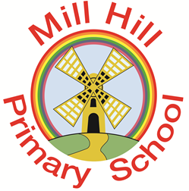

Aspire-Learn-Succeed

Phonics and early reading

Early Reading - Little Wandle Letters and Sounds Revised

Phonics (reading and spelling)
At Mill Hill Primary School, we believe that all our children can become fluent readers and writers. This is why we teach reading through Little Wandle Letters and Sounds Revised, which is a systematic and synthetic phonics programme. We start teaching phonics in Reception and follow the Little Wandle Letters and Sounds Revised progression, which ensures children build on their growing knowledge of the alphabetic code, mastering phonics to read and spell as they move through school.
As a result, all our children are able to tackle any unfamiliar words as they read. We also model the application of the alphabetic code through phonics in shared reading and writing, both inside and outside of the phonics lesson and across the curriculum.

Comprehension
At Mill Hill Primary School, we value reading as a crucial life skill. By the time children leave us, they read confidently for meaning and enjoy reading for pleasure. Our readers are equipped with the tools to tackle unfamiliar vocabulary. We encourage our children to see themselves as readers for both pleasure and purpose.
Because we believe teaching every child to read is so important, we have an Early Reading Leader who drives the early reading programme in our school. This person is highly skilled at teaching phonics and reading, and they monitor and support our reading team, so everyone across school teaches with fidelity to the Little Wandle Letters and Sounds Revised programme.
Little Wandle website: https://www.littlewandlelettersandsounds.org.uk/resources/for-parents/
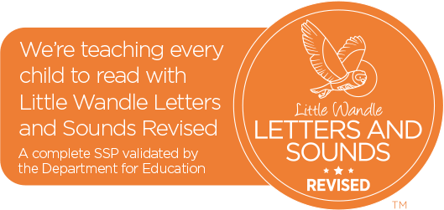
Parent information - Phonics
The resources on this page will help you support your child with saying their sounds and writing their letters. There are also some useful videos so you can see how they are taught at school and feel confident about supporting their reading at home. Find our full Reception and Year 1 teaching programme overview below to see what your child will learn and when.

Click here to view the following documents: Reception - Autumn 1 sounds; Reception - Autumn 2 sounds; Reception - Spring 1 sounds; Year 1 sounds; How to write capital letters

Support for phonics
These four videos show you how to pronounce the sounds. Notice how the children don’t add an ‘uh’ sound at the end, so they say: ‘t’ not ‘tuh’. Use the downloadable information to help your child remember how to write their letters and say their sounds.
Phase 2 sounds taught in Reception Autumn 1 - https://www.youtube.com/watch?v=-ZtjFIvA_fs
Phase 2 sounds taught in Reception Autumn 2 - https://www.youtube.com/watch?v=qDu3JAjf-U0
Phase 3 sounds taught in Reception Spring 1 - https://www.youtube.com/watch?v=DvOuc7cWXxc
Phase 5 sounds taught in Y1 - https://vimeo.com/742982775?rel=0

Additional useful videos
How we teach tricky words - https://vimeo.com/742989066?rel=0
How we teach blending - https://www.youtube.com/watch?v=IL5YUCPyC5I
A guide to alien words - https://vimeo.com/742989497?rel=0
How we teach phase 5 - https://vimeo.com/743021918?rel=0

All information taken from Little Wandle Revised: https://www.littlewandlelettersandsounds.org.uk/resources/for-parents/

Parent information - Supporting your child with reading
Although your child will be taught to read at school, you can have a huge impact on their reading journey by continuing their practice at home.
There are two types of reading book that your child may bring home:
A reading practice book. This will be at the correct phonic stage for your child. They should be able to read this fluently and independently.
A sharing book. Your child will not be able to read this on their own. This book is for you both to read and enjoy together.
Reading practice book
This book has been carefully matched to your child’s current reading level. If your child is reading it with little help, please don’t worry that it’s too easy – your child needs to develop fluency and confidence in reading.
Listen to them read the book. Remember to give them lots of praise – celebrate their success! If they can’t read a word, read it to them. After they have finished, talk about the book together.
Sharing book
In order to encourage your child to become a lifelong reader, it is important that they learn to read for pleasure. The sharing book is a book they have chosen for you to enjoy together.
Please remember that you shouldn’t expect your child to read this alone. Read it to or with them. Discuss the pictures, enjoy the story, predict what might happen next, use different voices for the characters, explore the facts in a non-fiction book. The main thing is that you have fun!
How to support your child with reading: https://player.vimeo.com/video/743027301?h=b26e4816a8&dnt=1&app_id=122963

Little Wandle website: https://www.littlewandlelettersandsounds.org.uk/resources/for-parents/

