DISHES AND THEIR ALLERGEN CONTENT – Mill Hill Primary School Spring/Summer Menu 2023 (a)

DISHES | 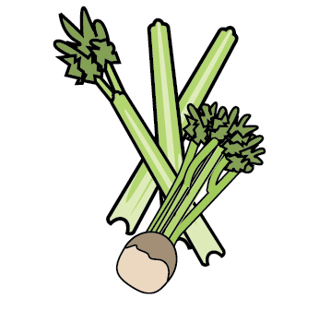 | 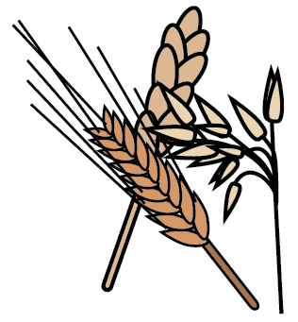 | 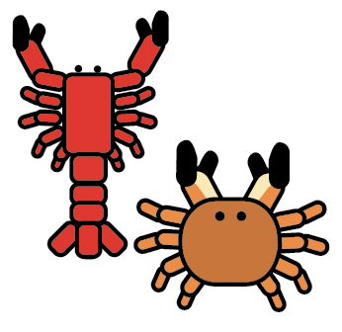 | 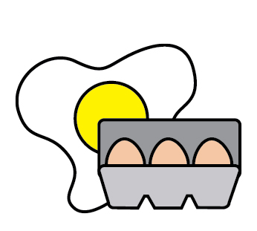 |  |  |  | 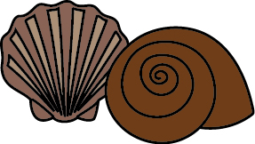 | 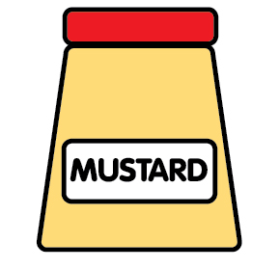 | 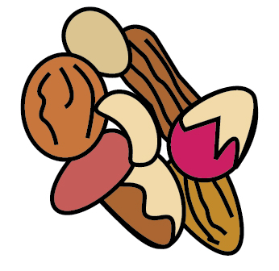 | 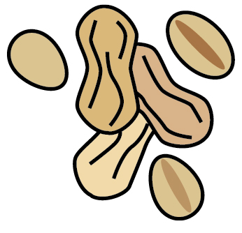 | 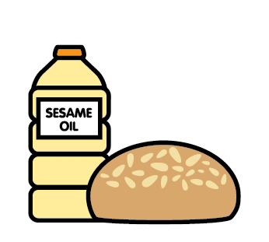 |  | 
 | Celery | Cereals containing gluten | Crustaceans | Eggs | Fish | Lupin | Milk | Mollusc | Mustard | Nuts | Peanuts | Sesame seeds | Soya | Sulphur Dioxide
Mac N Cheese |  | ✓ |  |  |  |  | ✓
Veggie Finger |  | ✓
Quorn Nuggets |  | ✓
Cheese & Onion Pastie |  | ✓ |  |  |  |  | ✓ |  | ✓ | ✓ |  |  | ✓ | Paslm Oil
Fishless Fingers |  | ✓
Meatballs in Tomato Sauce & Pasta |  | ✓
Mince & Dumplings |  | ✓ |  |  |  |  |  |  |  |  |  |  | ✓
Ham & Cheese Panini |  | ✓ |  |  |  |  | ✓ |  |  |  |  | ✓
Roast Chicken & Yorkshire Pudding |  | ✓ |  | ✓ |  |  | ✓ |  |  |  |  |  | ✓

Review date: |  | Reviewed by: |  |  | You can find this template, including more information at www.food.gov.uk/allergy

