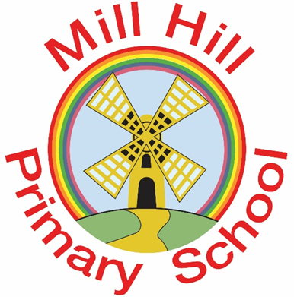
RE
Every pupil has an entitlement to religious education. It is a compulsory component of the basic curriculum and is taught alongside the National Curriculum. In these lessons we discover and explore a range of religious and non-religious views and make connections in the world. The religious education curriculum forms an important part of our school's spiritual, moral and social teaching. It also promotes education for citizenship and helps children become equipped for life in an inclusive society. At Mill Hill Primary School, we follow the Sunderland agreed syllabus (2021).

Right of withdrawal
Parents have right to withdraw their children from RE lessons or any part of the RE curriculum if they so wish, although only after they have given written notice to the school governors. The ERA also allows teachers to refuse to teach religious education, but only after they have given due notice of their intention to the school governors.

