

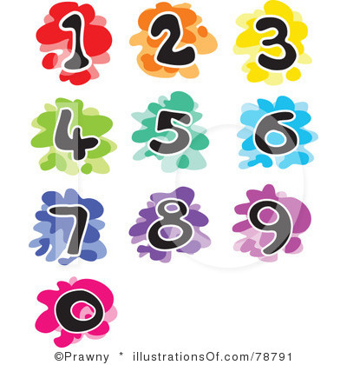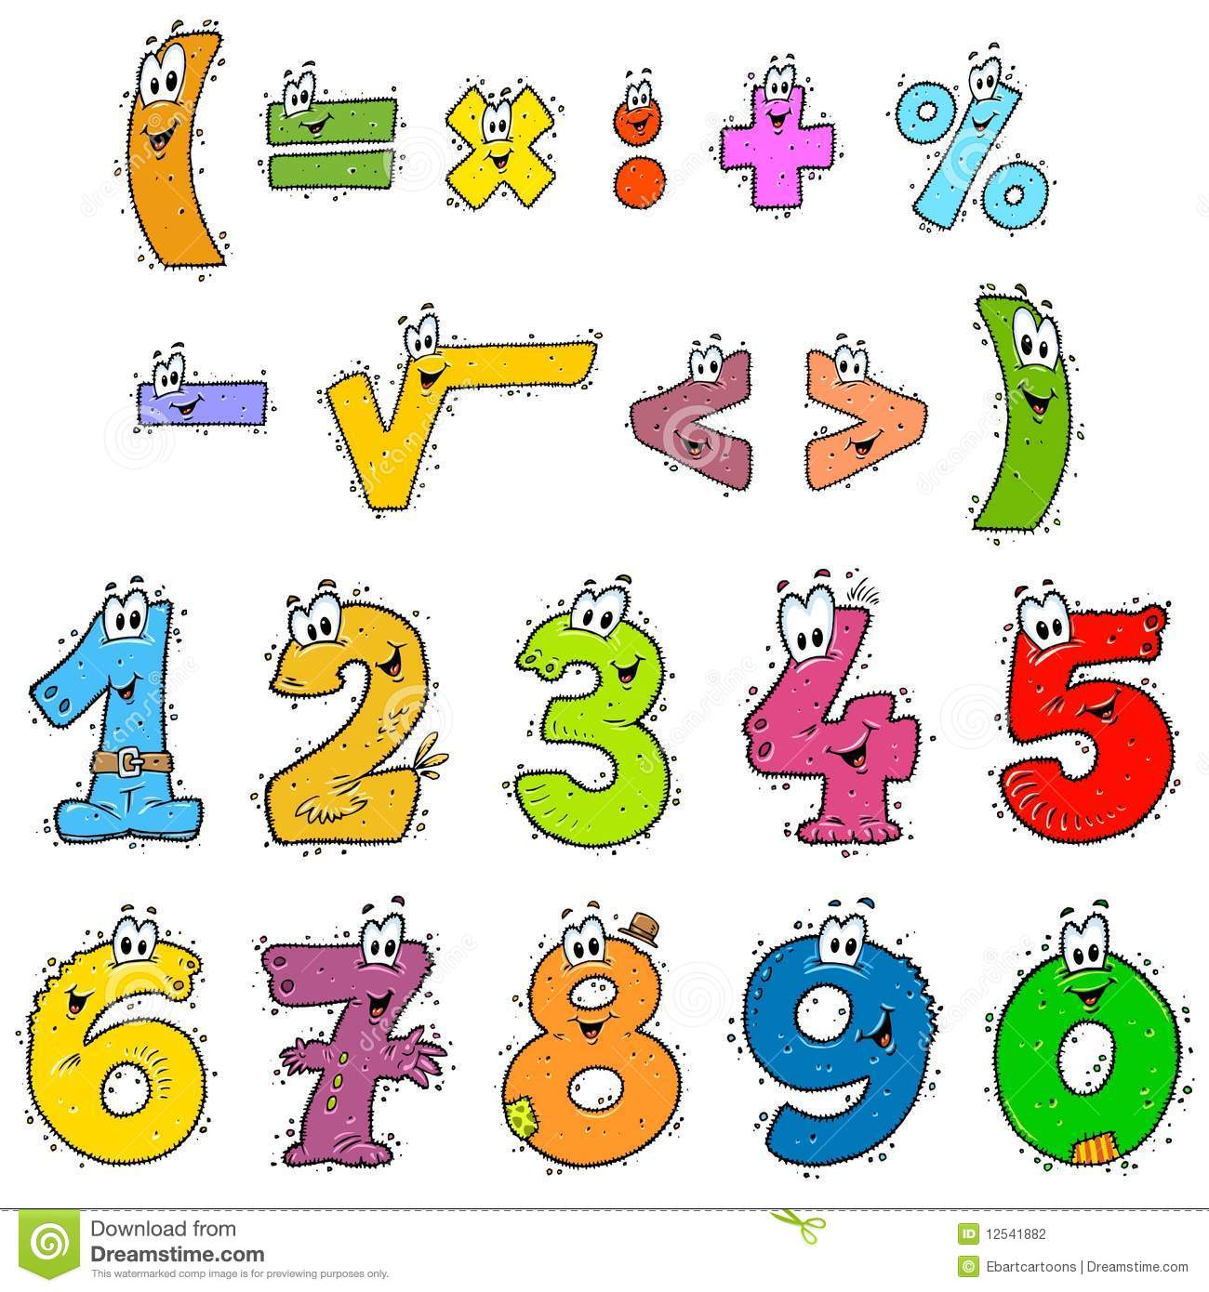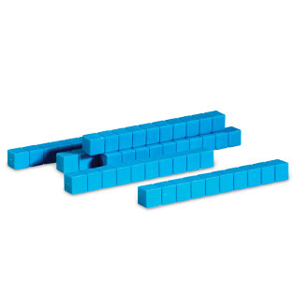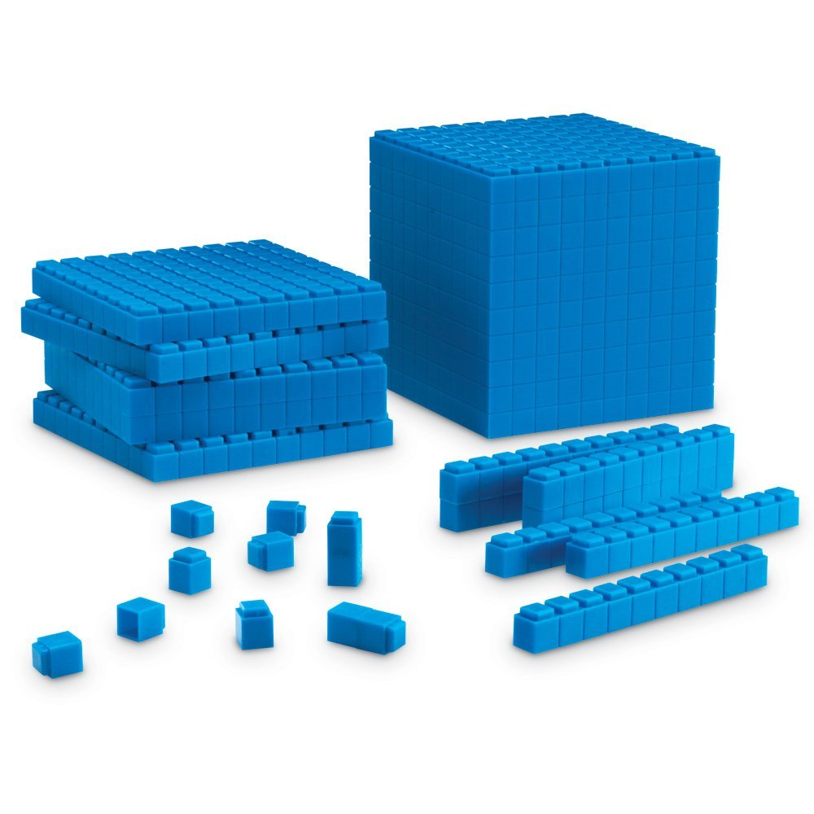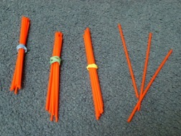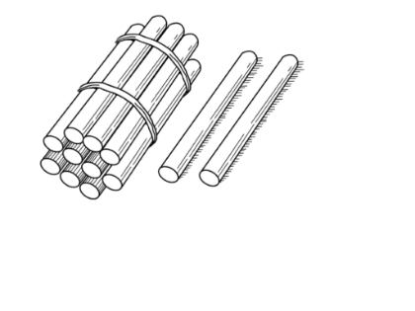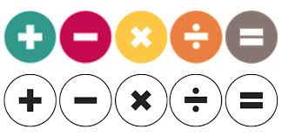

Mill Hill Primary School



**Progression in Multiplication**

**Using the CPA Approach**

September 2016

D. Osmond – Maths Subject Leader

******

Mill Hill’s Progression in Multiplication – using the CPA Approach

|  |  |  |  |
| --- | --- | --- | --- |
| ***STRATEGY*** | ***CONCRETE*** | ***PICTORIAL*** | ***ABSTRACT*** |
| **Doubling**  **and**  **Halving**  **Link and record**  **doubling to x2**  **and**  **halving to ÷2**  **Link and record halving to**  **finding**  **fractions of amounts**  **½ of .........**  **Can children**  **reason**  **about these concepts?**  **Why are they called doubles**  **/ halves?** | Use practical activities to show how to double and halve number.  IMG_2997      IMG_3004    Unifix  ½ of 14 = 7 or  Numicon Double 7  IMG_3004  Dice  Domino  Double 4  doubling-and-halving-board---a3  image?width=500&height=500&version=1398624789000  Halving and Doubling Mats – turn them around to show the **inverse.** | Draw pictures to show how to double and halve a number.          Use pictures to solve problems.  Tom ate some cherries. He ate half of them. These are the cherries left.  How many cherries  did he start with? | Partition a number and then double each part before recombining it back together.    Link doubles to addition double number sentences.  Partition a number, and then halve each part before recombining it back together (as doubling example above).  Apply understanding to solve problems and reason.  Write a number in each box to make this correct.      Progress to using larger numbers, using related facts and decimal numbers. |
| ***STRATEGY*** | ***CONCRETE*** | ***PICTORIAL*** | ***ABSTRACT*** |
| **Skip Counting**  **in**  **Multiples**  **of**  **2, 5 and 10**  ***Year 1 / 2***  The representation for the amount of groups supports children’s understanding of the written equation.  Count the groups as children are skip counting.  Number lines can be used in the same way as the bead string.  Children can use their fingers as they are skip counting, to develop an understanding of ***‘groups of’.***  ***Year 2 – progress to* Skip Counting**  **in**  **Multiples of 3** | Count in multiples supported by concrete objects in equal groups.  Four groups of 5: 5, 10, 15, 20  ***4 x 5 = 20***  Four groups of 2: 2, 4, 6, 10  ***2 x 4 = 8***    Actual fingers to support counting.    Numicon for counting in 5s and 2s and 10s.    Using coins: 1p, 2, 5p & 10p. | Use a number line or pictures to continue support in counting in multiples.      Dotted paper is used to create a visual representation for the different multiplication facts.  Each multiplication table has its own template, which is provided during taught units. | Verbal count in multiples of a number aloud.  Write sequences with multiples of numbers (e.g. 2, 4, 6, 8, 10 or 5,  10, 15, 20, 25 , 30)  Continue the sequence by shading more squares.  Include **missing box sequences** – horizontally and vertically set out.  ***15, \_\_\_, 25, 30, \_\_\_\_ etc***  Include **‘Spot the mistakes’** – explain with reasons.  ***30, 35, 40, 46, 50*** |

|  |  |  |  |
| --- | --- | --- | --- |
| ***STRATEGY*** | ***CONCRETE*** | ***PICTORIAL*** | ***ABSTRACT*** |
| **MULTIPLICATION:**  **Making**  **Equal Groups**  **and**  **Counting the Total.**  ***Year 1 / 2***  Ensure children use the vocabulary  ***‘groups of’***  when reading multiplication number sentences.  Use **actions** to make the **‘x’ sign**  when reading number sentences.  **In class or PE**  Make **human groups** using children and hoops or ropes to ensure children understand what ***‘a group’*** means. | How this would be represented as an equation will vary.  This shows 2 × 4. Can you show 4 x 2?      The importance should be placed on the vocabulary used alongside the equation.  Can you see **5 groups**?  How many plasticene balls are in **each group**? 2  So, there are 5 groups of 2. 5x2=*10 balls in total*  **or**    How **many groups** can you see now? **2 groups**  How many plasticene balls are in **each group**? 5  So, there are 2 groups of 5. 2x5=*10 balls in total*  small-group  small-groupsmall-groupsmall-group 1 ***group of 4*** makes 4 pupils  1 ***team of 4*** makes 4 pupils | This picture could represent  2 groups of 4 or 4 twice.                \_\_\_\_ x \_\_\_\_ = \_\_\_\_  **or**    \_\_\_\_ x \_\_\_\_ = \_\_\_\_ | 4 + 4 = 8  2 x 4 = 8 (Double 4)  \_\_ x 2 = 10  3 x \_\_ = 15  14 = \_\_ x \_\_  Solve missing number calculations. |

|  |  |  |  |  |
| --- | --- | --- | --- | --- |
| ***STRATEGY*** | ***CONCRETE*** | | ***PICTORIAL*** | ***ABSTRACT*** |
| **MULTIPLICATION:**  **Repeated Addition**  ***Year 1 / 2***  Children to apply skip counting to help find the totals of repeated additions. | Use a range of different objects, real-life and  linked to the wider curriculum and mathematical equipment, to add equal groups.    5 + 5 + 5 = 15  3 groups of 5 = 15  3 x 5 = 15 circles          5 + 5 = 10  2 groups of 5 = 10  2 x 5 = 10 cubes      5 + 5 + 5 + 5 + 5 + 5 + 5 + 5 =  8 groups of 5 = 40 or 8 x 5 = 40 beads      3 groups of 3 = 9  3 x 3 = 9 cubes | | 0  5 + 5 + 5 = 15  3 groups of 5 make 15 3 x 5 = 15 circles  Hands-Preview  5 groups of 5 make 20 4 x 5 = 20 fingers      How many apples in total?  3 + 3 + 3 = 9  3 groups of 3 = 9 | Write number sentences to describe objects and/or pictorial representations.  Link repeated addition to multiplication:  2 + 2 + 2 = 6  3 x 2 = 6  5 + 5 + 5 = 15  3 x 5 = 15  5 + 5 + 5 + 5 = 20  4 x 5 = 20  Solve missing number calculations.  4 x \_\_ = 40  \_\_ x 2 = 12  5+5+5+5+5+5+5+5  8 x 5 = 40  (8 groups of 5)  3 + 3 + 3 = 9  3 x 3 = 9  (3 groups of 3) |
| ***STRATEGY*** | | ***CONCRETE*** | ***PICTORIAL*** | ***ABSTRACT*** |
| **MULTIPLICATION:**  ***Year 2***  **Arrays to Show**  **Commutativity**  Concrete manipulatives  and images of familiar objects begin to be organised into arrays and, later, are shown alongside dot arrays.  It is important to discuss with children how arrays can be useful.  Pupils begin to understand  multiplication in a more abstract fashion, applying their skip counting skills to identify the multiples of the 10x, 2x, 5x and 3x tables.  The relationship between  multiplication and division also begins to be demonstrated.  Children should understand that an array and, later, bar models can represent different equations and that, as **multiplication** is **commutative,** the order of the multiplication does not affect the answer. | | Create arrays using counters/ cubes to show multiplication sentences.  http://www.australiancurriculumlessons.com.au/wp-content/uploads/2013/05/arrays-multiplication-division-lesson.jpg  3 groups of 6  6 + 6 + 6 = \_\_  3 x 6 = 18        http://www.australiancurriculumlessons.com.au/wp-content/uploads/2013/05/arrays-multiplication-division-lesson.jpg  6 groups of 3  3+3+3+3+3+3  6 x 3 = 18    .  3 groups of 5 = 15 cubes  Counting in 5’s.      5 groups of 3 = 15 cubes  Counting in 3’s. | Draw arrays in different rotations to find  commutative multiplication sentences..  ts_3_8_wi-5  ts_3_8_wi-5  ts_3_8_wi-5ts_3_8_wi-5ts_3_8_wi-5 **3** x 6 = 18  ts_3_8_wi-5ts_3_8_wi-5ts_3_8_wi-5  ts_3_8_wi-5 **6** x 3 = 18  ts_3_8_wi-5ts_3_8_wi-5    Notice the **‘=’** sign is at the start of the number sentence.  ts_3_8_wi-5ts_3_8_wi-5ts_3_8_wi-5 15 = **3** x 5  Invite children to read the  number sentence.    ts_3_8_wi-5  ts_3_8_wi-5ts_3_8_wi-5ts_3_8_wi-5 15 = **5** x 3 | Use an array to write multiplication sentences and reinforce repeated addition.  5 + 5 + 5 = 15  3 + 3 + 3 + 3 + 3 =15  5 x 3 = 15  3 x 5 = 15  Solve missing number sentences.  15 = 5 x \_\_\_  3 x \_\_\_ = 15  Write the correct sign the box. |

|  |  |  |  |  |  |  |
| --- | --- | --- | --- | --- | --- | --- |
| ***STRATEGY*** | ***CONCRETE*** | | | ***PICTORIAL*** | | ***ABSTRACT*** |
| **MULTIPLICATION:**  **Bar Modelling to Represent the Parts,**  **the Whole**  **and the**  **Number of**  **Parts** | There are 4 bags of sweets, with 3 sweets in each bag. How many sweets are there altogether?          There are 3 school bags, with 5 books in each one. How many books are there altogether?      **Use real-life or mathematical equipment** to model and scaffold learning before the use of the pictorial bar model or alongside the pictorial bar model if required.  **Cuisenaire rods** can be used to create bar models that represent multiplications. | | |  | | 3 + 3 + 3 + 3 + 3 = 12  3 x 4 = 12  5 + 5 + 5 = 5 x 3 = 15  Solve missing number  sentences.  How many groups of ten will make 15?    5 = 15  Solve problems. |
| ***STRATEGY*** | | ***CONCRETE*** | ***PICTORIAL*** | | ***ABSTRACT*** | |
| **MULTIPLICATION:**  **Part – Part Whole Model**  This model can help to establish the inverse relationship between multiplication and division.  This link should be made explicit from early on, using the language of the part-part-whole model, so that pupils develop an early understanding of the relationship between multiplication and division.  **Bar models (with Cuisenaire rods**) should be used to identify the whole, the size of the parts and the number of parts. | | Use Cuisenaire rods to replicate the bar model.  8 | Bar models. | | What multiplication and division equations can you write for each bar model?  Prove that the equations are correct using concrete equipment. | |

|  |  |  |  |
| --- | --- | --- | --- |
| ***STRATEGY*** | ***CONCRETE*** | ***PICTORIAL*** | ***ABSTRACT*** |
| **COLUMN**  **MULTIPLICATION:**  ***Year 3***  **Begin TU x U without carrying.**  **Remind children about lining up their numbers clearly in columns.**  **Always estimate, then check the answer.**  **20 x 3 = 60**  Use place value and related facts – little numbers to work out big numbers to help. | Children should continue to be supported by Dienes equipment and / or place value counters at this stage of multiplication. | Children can draw ***‘groups of’*** to support them.  D:\DCIM\147___07\IMG_4583.JPG  D:\DCIM\147___07\IMG_4582.JPG | 21 x 3 = 63  **T U**  (3 x 1 = 3)  (3 x 20=60)    Write out what you are solving next to the answer.  Solve missing number sentences. |

|  |  |  |  |  |  |  |
| --- | --- | --- | --- | --- | --- | --- |
| ***STRATEGY*** | | ***CONCRETE*** | ***PICTORIAL*** | | ***ABSTRACT*** | |
| **COLUMN**  **MULTIPLICATION:**  ***Year 3***  **Progress to**  **TU x U**  **with carrying / exchanging.**  **Remind children about lining up their numbers clearly in columns.**  **Always estimate and check the answer.** | Children should continue to be supported by Dienes equipment and / or place value counters at this stage of multiplication. | D:\DCIM\147___07\IMG_4581.JPGD:\DCIM\147___07\IMG_4580.JPGChildren can draw ***‘groups of’*** to support them. | | 16 x 3 = 48  **T U**  (3 x 6 = 18)  (3 x 10 =30)  (30 +10= 40)  Write out what you are solving next to the answer.  Solve missing number sentences. | |
| ***STRATEGY*** | | ***CONCRETE*** | ***PICTORIAL*** | | | ***ABSTRACT*** | |
| **COLUMN**  **MULTIPLICATION:**  ***Year 4***  **Begin HTU x U without carrying / exchanging.**  **Then progress to exchanging.**  **Remind children about lining up their numbers clearly in columns.**  **Always estimate the answer.**  **200 x 4 = 800**  D:\DCIM\147___07\IMG_4591.JPG | | Children should continue to be supported by Dienes equipment and / or place value counters at this stage of multiplication.  215 x 4 = 860    215 partitioned into 200 (two groups of one hundred), 10 (one ten) and 5 (five units/ones).  Make 215 four times.  **Multiply the Units/ Ones first.**  **Hundreds Tens Units / Ones**  D:\DCIM\147___07\IMG_4584.JPGD:\DCIM\147___07\IMG_4584.JPGD:\DCIM\147___07\IMG_4586.JPG  D:\DCIM\147___07\IMG_4585.JPG  **Exchange**  units for tens.  **Multiply the**  **Tens**  4 x 10 =40  Plus the two  tens (20)  = 6 tens (60)  D:\DCIM\147___07\IMG_4586.JPG  **Multiply the Hundreds**  If 4 x 2 = 8, then........  4 x 200 =800 (4 groups of  two hundred). | Children can draw  D:\DCIM\147___07\IMG_4590.JPGD:\DCIM\147___07\IMG_4588.JPGD:\DCIM\147___07\IMG_4587.JPG ‘***gr oups of’*** to support them. | | | **Units**  (4 x 5 = 20)  **Tens**  (4 x 10 = 40  40 + 20 = 60)  **Hundreds**  (4 x 200 = 800)  Use place value and related facts – little numbers to work out big numbers to help.  Solve missing number sentences. | |
| ***STRATEGY*** | | ***CONCRETE*** | ***PICTORIAL*** | ***ABSTRACT*** | | |
| **COLUMN**  **MULTIPLICATION:**  ***Year 5***  **TU x TU without carrying exchanging.**  **Then progress to exchanging.**  **Remind children about lining up their numbers clearly in columns.**  **Always estimate the answer.**  20 x 13= 260 | | Children can still be supported by place value counters at this stage of multiplication.  Calculate 18 x 13 = \_\_\_\_\_  Estimate the answer first. 20 x 13= 260RIMG0008    RIMG0008RIMG0008 | 1 8 x 13 = 234  IMG_4594    IMG_4595  RIMG0007  RIMG0008RIMG0008RIMG0007RIMG0007  RIMG0008  Children can use the law of **commutativity** to draw different *‘****groups of’****.* | Start with long multiplication, reminding the children about lining up their numbers clearly in columns.  If it helps, children can write out what they are solving next to their answer.  **Estimate the answer**  **20 x 13 = 260**  IMG_4593  **Estimate the answer 70x 60 = 4,200**      Start with the units (ones), then the tens. Then add the answer together. Stress the importance of using place value to ensure that children write then numbers in the correct position.  IMG_4592  Progress to......  Ensure children  understand why zero  is used as a place  holder. | | |

|  |  |  |  |
| --- | --- | --- | --- |
| ***STRATEGY*** | ***CONCRETE*** | ***PICTORIAL*** | ***ABSTRACT*** |
| **COLUMN**  **MULTIPLICATION:**  ***Year 5/6***  **HTU x TU without carrying exchanging.**  **Then progress to exchanging.**  **Remind children about lining up their numbers clearly in columns.**  **Always estimate the answer.**  **Can children explain why *‘zero’* is used as place holder?** | Children can still be supported by apparatus if needed.  RIMG0008 |  | **2 8 6 x 2 9 is approximately 300 x 30 = 9,000**  **Th H T U**  **2 8 6**  **X 2 9**  **\_\_\_\_\_\_\_\_\_\_\_\_\_\_\_\_\_**  **5 4 (9 x 6)**  **7 2 0 (9 x 80)**  **1 8 0 0 (9 x 200)**  **1 2 0 (20 x 6)**  **1 6 0 0 (20 x 80)**  **4 0 0 0 (20 x 200)**  **\_\_\_\_\_\_\_\_\_\_\_\_\_\_\_\_\_**  **8 2 9 4**  **\_\_\_\_\_\_\_\_\_\_\_\_\_\_\_\_\_**  **2**  This expanded method is cumbersome. There is plenty of incentive to move on to a more efficient method. Before doing so, ensure children fully understand the value of each digit.  **Th H T U**  **2 8 6**  **X 2 9**  **7 5**  **2 5 7 4 (9 x 286)**  **1 1**  **5 7 2 0 (20 x 286)**  **1**  **8 2 9 4** | |