Mill Hill Primary School



**Progression in Division**

**Using the CPA Approach**

September 2023



Mill Hill’s Progression in Division – using the CPA Approach

|  |  |  |  |  |
| --- | --- | --- | --- | --- |
| ***STRATEGY*** | ***CONCRETE*** | ***PICTORIAL*** | ***ABSTRACT*** | |
| **DIVISION:**  **Sharing Objects**  ***Reception /***  ***Year 1 / 2***  Children should become familiar with division equations through working practically.  Make links with fractions and division.  Sharing into two halves (2/2).  ***½ of 10 = 5***  ***or***  ***10 shared into 2 groups is ......*** | 10 ÷ 2 = 5  10 sweets shared fairly / equally into 2 groups?  I have 10 cubes, can you share them equally in 2 groups?  Count 10 sweets accurately before sharing fairly... then......***one for me, one for you.....***  10chunked5    10chunked5  **Assess -** Do children see the link between **÷2** (sharing fairly into two groups) and **halving?**    Share fairly **15** **÷ 3 = 5**  **15** shared **equally** into **3**  **groups** using apparatus. | Children use pictures or shapes to share quantities.  Draw an equal number of apples for each basket.    There are **5 apples** in each basket.  Draw an equal number of apples for each basket.  There are 5 apples in each basket.  Draw an equal number of apples for each basket.  There are 5 apples in each basket.  Share an equal number of scissors for each tub. 10 ÷ 2 = 5    6 teddies shared into 2 hoops = 3  6 ÷ 2 = 3    15÷ 5 = 3 | Share 8 buns between two people.  8 ÷ 2 = 4  **Please ensure the correct language is used when sharing fairly- it is different to grouping. See next page.** | |
| ***STRATEGY*** | ***CONCRETE*** | ***PICTORIAL*** | | ***ABSTRACT*** |
| **DIVISION:**  **Grouping**  **‘vs’**  **Sharing Fairly**  ***Year 1 / 2***  ***Take great care HOW you word a division number sentence.***  ***‘Shared into groups of’***  ***is different to***  ***‘shared into so many groups.’***  *(This is*  *sharing)*  ***DO NOT confuse grouping with sharing fairly into groups*** | Divide quantities into *‘****equal groups’.***  Use cubes, counters, objects or place value counters to aid understanding or link to real-life equipment and those connected to the wider curriculum.  ***Groups of***  If we have ten cubes, sweets or forks and we put them into **groups of two,** there are **5 groups**. 10 ÷ 2 = 5 (counting in 2’s)        Or if we have ten cubes, sweets or forks and we share / divide / put them **into 5 groups, there are 2 sweets in each group.** (Sharing fairly)  10 ÷ 5 = 2 or 1/5 of 10  10chunked5  10chunked510chunked5  10shared5  10shared510shared510shared5  10shared510shared510shared5  Compare each number sentence.  *What’s the same and what’s different?* | ***10 shared*** *into*  ***2 groups***  10 ÷ 2 = 5 forks  ***10 shared*** *into*  ***‘groups of’ 2***  10 ÷ 2 = 5  groups        ***This is grouping. This is sharing fairly.***  ***Count from zero in groups of 2 to ten.***    http://gcamath3.weebly.com/uploads/9/1/4/0/9140392/200455_orig.jpgThink of the bar as a whole. Split it into the number of groups you are dividing by and work out how many would be within each group. | | 10 ÷ 2 = 5  Include missing box calculations.  10 ÷ __ = 5  Solve missing number sentences.  ___ ÷ 5 = 4 |

|  |  |  |  |  |  |
| --- | --- | --- | --- | --- | --- |
| ***STRATEGY*** | ***CONCRETE*** | ***PICTORIAL*** | | ***ABSTRACT*** | |
| **DIVISION:**  **Grouping**  ***Year 1 – count in multiples of 10, 2, and 5.***  Link fractions of amounts with division. Record as a fraction of an amount.  **Inverse**  Link grouping with knowledge of times tables.  ***Year 2 – Division facts (10x, 2x, and 5x table)***  ***Year 2 – count in multiples of 3.*** | Place the ‘groups of 5’ on top or underneath the 20. How many ‘5s’?    Count 20 cubes.  RIMG0054    RIMG0057  Make one group of 5.  RIMG0058  Make another  group of 5.  RIMG0058  RIMG0061    Make another  group of 5.  RIMG0059  Make another  group of 5.  Make clear links to multiplication: 4 ‘5s’ 4 x 5. | Draw shapes to show jumps in groups. The number of jumps equals the number of groups.  **20** shared into **groups of 5** 12 ÷ 5 = 4  Draw 20 stars.      Then draw rings around to make groups of 5.      There are ____ groups of 5 in total. (4 x 5 = 20)  Progress to using multiplication facts to help. Count in 5’s  1 group of 5 1 group of 5 1 group of 5 1 group of 5        5 10 15 20  Progress to introducing a number line. | 20 ÷ 5 = 4  1/5 of 20 =  12 ÷ 4 = 5  ¼ of 12 =  Solve missing number sentences.  20 ÷ __ = 5 | |

|  |  |  |  |  |  |
| --- | --- | --- | --- | --- | --- |
| ***STRATEGY*** | ***CONCRETE*** | ***PICTORIAL*** | | ***ABSTRACT*** | |
| **DIVISION:**  **Grouping**  ***Year 2/3***  Link fractions of amounts with division. Record as a fraction of an amount.  **Inverse**  Link grouping with knowledge of times tables.  ***Year 2 – Division facts (10x, 2x, and 5x table)***  ***Year 2 – count in multiples of 3.***  ***Year 3*** *-* ***Division facts (10x, 2x, and 5x, 3x and 4x table)***  ***Year 3*** *– progress to show grouping by partitioning using a number line.* | **Year 2 -** Grabbing groups of .....    **15** shared into **groups of 3** **15** **÷ 3 = 5**      **Link to fractions.**  1/3 of 15 = 5  Use real objects.  How many 3’s?  How many groups of 3 can you make with 24?  **___ x 3 = 24**  RIMG0043  RIMG0043  RIMG0045  RIMG0045 | or 1/3 of 18 is 6 **Year 2**  Image result for fractions of amounts one third of 18  .  **Year 3** –showing progression when **dividing** by **4**      Use knowledge of multiplication facts.  *If you know 5 x4 is ........* | 15 ÷ 3 = 5  5 x 3 = 15  1/3 of 15 is....  3 x 5 = 15  24 ÷ 3 = 8  8 x 3 = 24  1/3 of 24 is....  3 x 8 = 24  28 ÷ 7 = 4  Divide 28 into groups of 7. How many groups will there be?  Solve missing number sentences.  28 ÷ __ = 7 | |

|  |  |  |  |  |  |
| --- | --- | --- | --- | --- | --- |
| ***STRATEGY*** | ***CONCRETE*** | ***PICTORIAL*** | | ***ABSTRACT*** | |
| **DIVISION:**  **Grouping**  **using Partitioning**  ***Year 3***  ***Recall and Use Division facts (10x, 2x, and 5x, 3x and 4x table)***  ***Year 3*** *– progress to show grouping by partitioning using a number line.* | 42 ÷ 3 = 14 Use Dienes equipment.  How many groups of 3 can you make with 42?  Use knowledge of multiplication facts (inverse).  If I know 3 x 10 is .......    Progress to using a number line to show jumps in groups. The number of jumps equals the number of groups.  RIMG0047  RIMG0048Progress to.....  RIMG0048 | Children use pictures or shapes to group quantities.  42 ÷ 3 = 14  RIMG0050RIMG0050RIMG0049    RIMG0048 Progress to.....  RIMG0050    RIMG0051Partitioning cards are abstract but can used alongside concrete and pictorial representations.  RIMG0052RIMG0052  + | 42 ÷ 3 = 14  Solve missing number sentences.  ___ ÷ 3 = 27 | |

|  |  |  |  |
| --- | --- | --- | --- |
| ***STRATEGY*** | ***CONCRETE*** | ***PICTORIAL*** | ***ABSTRACT*** |
| **DIVISION:**  **Part – Part- Whole Model**  This strategy emphasizes the **relationship** between **division** and **multiplication**.  Children use arrays of concrete manipulatives and images of familiar objects to find division equations.  Link fractions of amounts with division.  This must be recorded alongside as a fraction. | Can you write 2 division number sentences?  Can you write 2 multiplication number sentences?  Prove it! Show using the cubes.  Explain and record. | Draw an array and use lines to split the array into groups to make multiplication and division sentences.      Dot arrays can be used to develop a more abstract concept of division. | 1/5 of 15 = 3    1/3 of 15 = 5  20 ÷ 4 = 5  ¼ of 20 = 5  20 ÷ 5 = 4  1/5 of 20 = 4  Find the **inverse** of multiplication and division sentences by creating four linking number sentences (fact families)  7 x 4 = 28  4 x 7 = 28  28 ÷ 7 = 4  28 ÷ 4 = 7 |

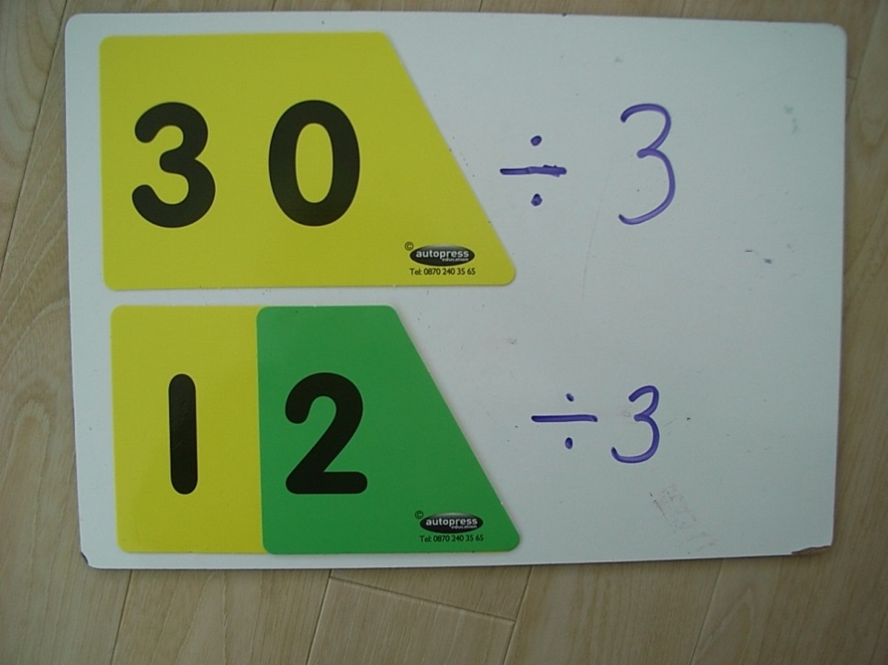

|  |  |  |  |
| --- | --- | --- | --- |
| ***STRATEGY*** | ***CONCRETE*** | ***PICTORIAL*** | ***ABSTRACT*** |
| **DIVISION:**  **Remainders**  **by**  **Grouping**  ***Year 3***  Children must **read** the number sentence correctly using language ***‘groups of’.***  Do they understand what it means?  ***Use knowledge of multiplication facts – the inverse operation.*** | 14 ÷ 3 = 4 **r** 2  Collect / count fourteen objects.  Children say*: I need to share / divide 14 objects into* ***groups of 3*.**  ea337eb673ac63a9df69d6c5ddb7624b  ea337eb673ac63a9df69d6c5ddb7624b  20 ÷ 3 = 6 **r** 2    .  **Grouping using Partitioning**  43 ÷ 3 = 6 **r** 2 If I know 3x10 is 30......  Bead string to model remainders | Draw dots and group them to divide an amount and clearly show a remainder.    14 ÷ 3 = 4 **r** 2  ***1***    23 ÷ 2 =  Jump forward in equal jumps on a number line then see how many more you need to jump to find a remainder.    Use knowledge and recall of multiplication facts.    Make links with fractions. 1/8 of 53 is ... | Complete written divisions and show the **remainder** using **r.**  20 ÷ 3 = 6 **r** 2  Progress to  HTU ÷ U  196÷ 6 = 6 **r** 4      If you know 3x6 is 18, then ....  RIMG006330x6 =.... |

|  |  |  |  |  |  |
| --- | --- | --- | --- | --- | --- |
| ***STRATEGY*** | ***CONCRETE*** | | ***PICTORIAL*** | ***ABSTRACT*** | |
| **DIVISION:**  **By**  **Grouping**  ***Year 4***  **Formal Written (Bus Stop) Method**  **without Carrying**  **Divide numbers up to 3 digits by a one-digit number**  **Formal Written**  **(Bus Stop)**  **Method**  **with Remainders**  **Divide numbers up to 3 digits by a one-digit number** | Using place value counters to support the formal written method (bus stop method). 248 ÷ 2 = or ½ of 248 =    **Start with the biggest place value**.    Step 1: How many groups of two  can be made with 200?  **1 group** of 200. (1x200=200)  Step 2: How many groups of two  can be made with 40?  **2 groups** of 20. (2x20 =40)  Step 3: How many groups of two  can be made with 8?  **4 groups** of 2. (4x2=8)  Step 1: How many groups of three  can be made with 300?  **1 group** of 300. (1x300=300)  Step 2: How many groups of three  can be made with 60?  **2 groups** of 30. (2x30 =60)  Step 3: How many groups of three  can be made with 7?  **2 groups** of 3 and **1 remainder.**  2x3=6 and 1 remainder | Instead of using counters, children can draw groups with dots and circles to support the formal written (bus stop) method.  http://www.studyzone.org/testprep/math4/d/division2.gif  Encourage them to move towards counting in multiples to divide more efficiently. | | Begin with divisions that divide equally with no remainders.    Divisions with a remainder.  1 2 2 **r** 1  .  **3** **3 6 7** |

|  |  |  |  |  |
| --- | --- | --- | --- | --- |
| ***STRATEGY*** | ***CONCRETE*** | ***PICTORIAL*** | ***ABSTRACT*** | |
| **DIVISION:**  **by**  **Grouping**  ***Year 5***  **Formal Written (Bus Stop) Method with Carrying**  **Divide numbers up to 4 digits by a one-digit number** | Using place value counters to support the formal written method.    192 ÷ 6 =    **Exchange** 100 for ten 10’s    19 tens into groups of 6  (19 put into groups of 6 =190)  How many groups of 6 make 180?  **Three** groups.  So that’s 30 x 6 is 180. Now exchange the remaining 10 for ten 1’s.    How many groups of 6 can be made with 12?  **Two** groups  So 192 ÷ 6 = 32 | Instead of using counters, children can draw groups with dots and circles to support the formal written method.  http://www.studyzone.org/testprep/math4/d/division2.gif  Encourage them to move towards counting in multiples to divide more efficiently. | 192 ÷ 6 = 32    **Step 1:** How many groups of 6 can you make with 1?  *None, so carry the one*  *hundred over to the*  *‘Tens’ column*  ***Remember....***  *10 groups of 10 make*  *100*  **Step 2:** How many **‘groups of 6’** can you make with **19 tens**?  *Three remainder 1. Carry the 1 ten over to the ‘Units’.*  **Step 3:** How many **‘groups of 6’** can you make with **12**?  *2 groups of six*  c  One remainder 4. Carry the 4 tens over to the ‘Unit colum |

|  |  |  |  |  |
| --- | --- | --- | --- | --- |
| ***STRATEGY*** | ***CONCRETE*** | ***PICTORIAL*** | ***ABSTRACT*** | |
| **DIVISION:**  **by Grouping**  ***Year 6***  **Formal Written Method**  **(Bus Stop)**  **Move into decimal places to**  **Divide the total accurately.** | RIMG0061 |  |  |