DISHES AND THEIR ALLERGEN CONTENT – Mill Hill Primary School (Summer Menu Week 3 Friday)

DISHES | 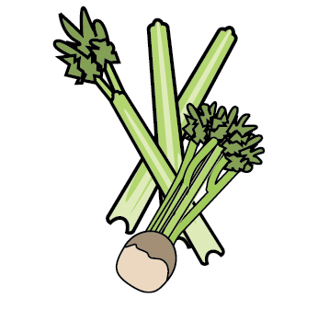 | 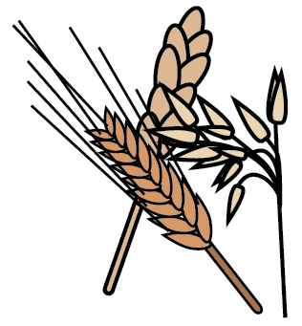 | 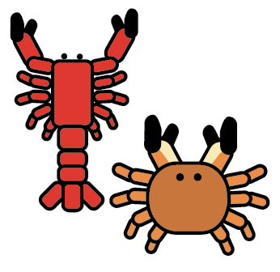 | 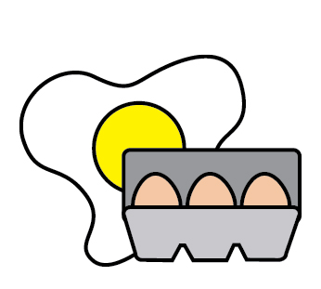 | 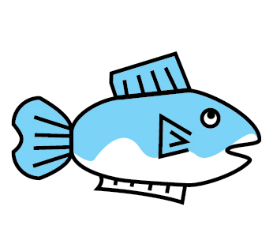 | 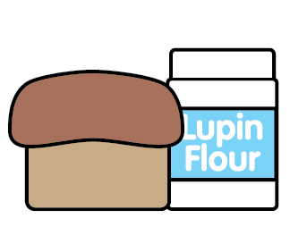 |  | 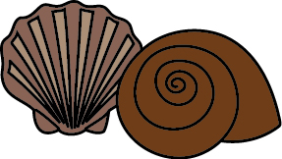 | 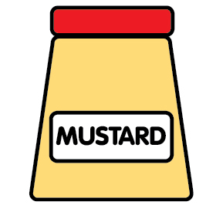 | 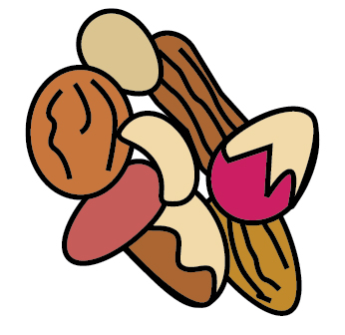 | 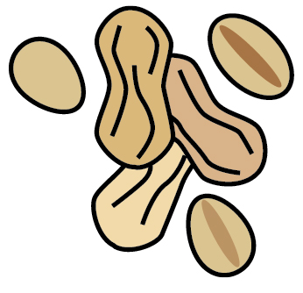 | 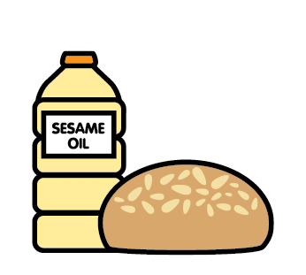 |  | 
 | Celery | Cereals containing gluten | Crustaceans | Eggs | Fish | Lupin | Milk | Mollusc | Mustard | Nuts | Peanuts | Sesame seeds | Soya | Sulphur Dioxide
Veggie Fingers |  | ✓
Battered Fish |  | ✓ |  |  | ✓
Chips & Veg
Jacket Potato with cheese, tuna mayo or beans |  |  |  | ✓ | ✓ |  | ✓
Sandwiches with ham, cheese, tuna, chicken, egg mayo |  | ✓ |  | ✓ | ✓ |  | ✓
Chocolate Orange Muffin |  |  |  |  |  |  | ✓
Ice Cream |  |  |  |  |  |  | ✓
Salad bar/bread |  | ✓ |  |  |  |  |  |  |  |  |  | M/C

Review date: |  | Reviewed by: |  |  | You can find this template, including more information at www.food.gov.uk/allergy

