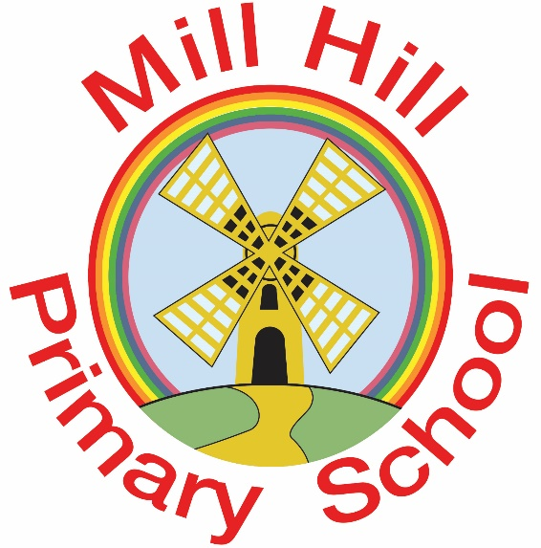

Aspire-Learn-Succeed

Charging Policy

MILL HILL PRIMARY SCHOOL
CHARGING POLICY

Introduction

All education during normal hours is free. We do not charge for any activity undertaken as part of the National Curriculum with the exception of individual or group music tuition or extra-curricular sports clubs. The governing body reserves the right to make a charge for the following activities which may be organised by school:

- Any materials, books, instruments or equipment where the child’s parent/carer wishes to own them
- Additional curriculum activities
- Individual or group music tuition

Breakfast Club/After School Club

- Bookings for breakfast and after school club must be made via Parentpay and paid for in advance.

- Breakfast club is before the school day starts from 8.00am – 9.00am (the start of school).
The charge is £3.00 per day.

- After school club runs Monday to Thursday from 3.25pm (end of the school day) until 5.30pm at a cost of £8.00, a half session until 4.30pm at a cost of £5.00.

Uncollected children
If a named adult is unable to collect a child at the end of the school day and the child is placed in after school club the parent will be charged at the appropriate rate.

Voluntary Contributions

When organising school trips or visits that enrich the curriculum and educational experience of the children, the school invites parents to contribute to the cost of the trip. If we do receive insufficient contributions the trip may have to be cancelled. If a trip goes ahead it may include children whose parents/carers have not paid any contribution.

The following is a list of educational activities organised by the school which require a voluntary contribution from parents/carer. The list is not exhaustive:

- Visits to museums
- Activities that require transport expenses
- Outdoor adventure activities
- Visits to theatres
- Musical events

If a parent wishes their child to take part in a school trip or event but is unwilling or unable to make a voluntary contribution , we do allow the child to participate fully in the trip or activity. Sometimes the school pays additional cots in order to support the visit. Parents have the right to know how each visit is funded. The school provides information on request.

Residential Visits

If the school organises a residential visit in school time or mainly in school time, full payment must be made to cover the cost of board and lodging for the visit. Voluntary contributions are requested to cover the cost of transport and any additional activity undertaken during the trip. Parents receiving the following allowances may not be charged: (This can be discussed on an individual basis)

- Universal credit
- Income-based jobseeker’s allowance
- Support under part V1 of the immigration and Asylum Act 1999
- Child Tax Credit, provided the parent is entitled to Working Tax Credit and their annual income does not exceed the current national provision
- Guaranteed State Pension Credit

Music Tuition

All children study music as part of the normal school curriculum, we do not charge for this.

There is a charge for individual or group music tuition if this it not part of the national curriculum. The peripatetic music teachers teach individual or small group lessons. We make a charge for these lessons. Parents in receipt of state benefits are exempt form payment. We give parents information about additional music tuition at the start of each term.

Activities Outside School Hours

Charges may be made for activities that take place wholly outside school hours and which are not part of the national curriculum. Where there are not enough contributions to make the activity possible and there is no way to make up the shortfall, then the activity could be cancelled.

Pupil Premium

Mill Hill Primary School reserves the right to utilise the Pupil Premium Grant t cover the cost of contributions to pupils. For 2023/24 the criteria for Pupil Premium eligibility is free school meals ever 6, a child from a service family or a looked after child/child adopted from care.

Breaking and Damage to School Property

The governing body of Mill Hill Primary School reserve the right to seek reparation from parents where their children cause breakages or damage to school property. Wherever possible, three quotations will be sourced in order to establish the cost of the repair.

